Report For Rollerball – Dean Jackson

Description

Rollerball is all about physics and control, the game is similar to an endless runner with a twist the player uses the board to move the player not the actual player. The user rotates the board left and right which will move the ball and certain other objects on the board, the aim of the game is to last as long as possible and collect as many coins as possible. To make the game interesting there are obstacles in the way of the player, for example there could be a massive boulder rolling across the path or just certain walls to avoid. There are powerups and power downs. For example bigger ball and smaller ball which changes the size of the ball and changes the collider which makes it harder or easier to collide with other gameobjects this can save the player from certain obstacles but make it harder to collect coins. In the game there are multiple variations of traps and all are randomly generated. The player has multiple stages getting harder and harder, the player must “fall down” to the next level which gives a good feel of progression.

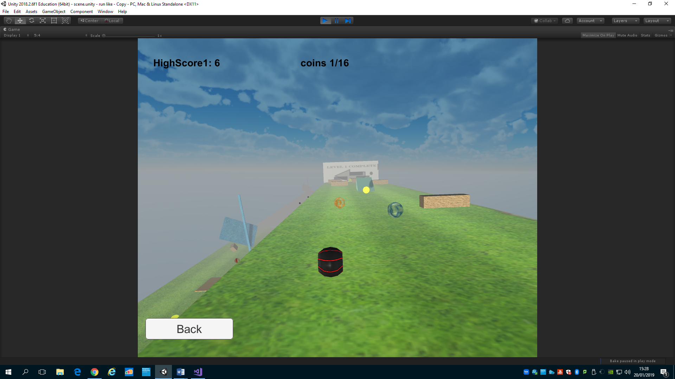

Visual Design

The player

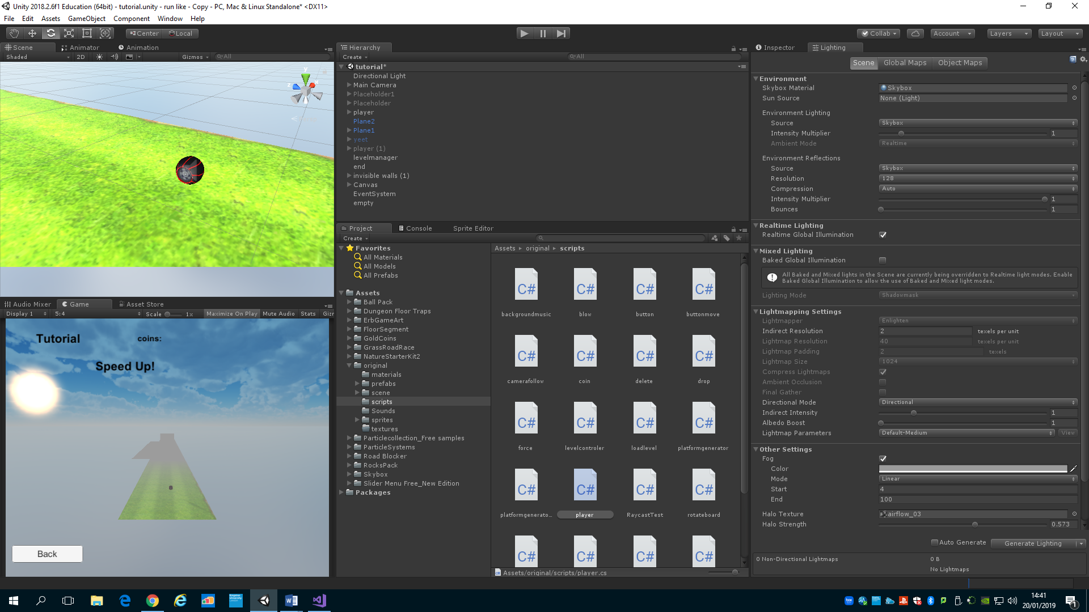

The player’s wheel object is from the unity assets store. It fits the purpose as it is a stray wheel that has rolled away.

The board

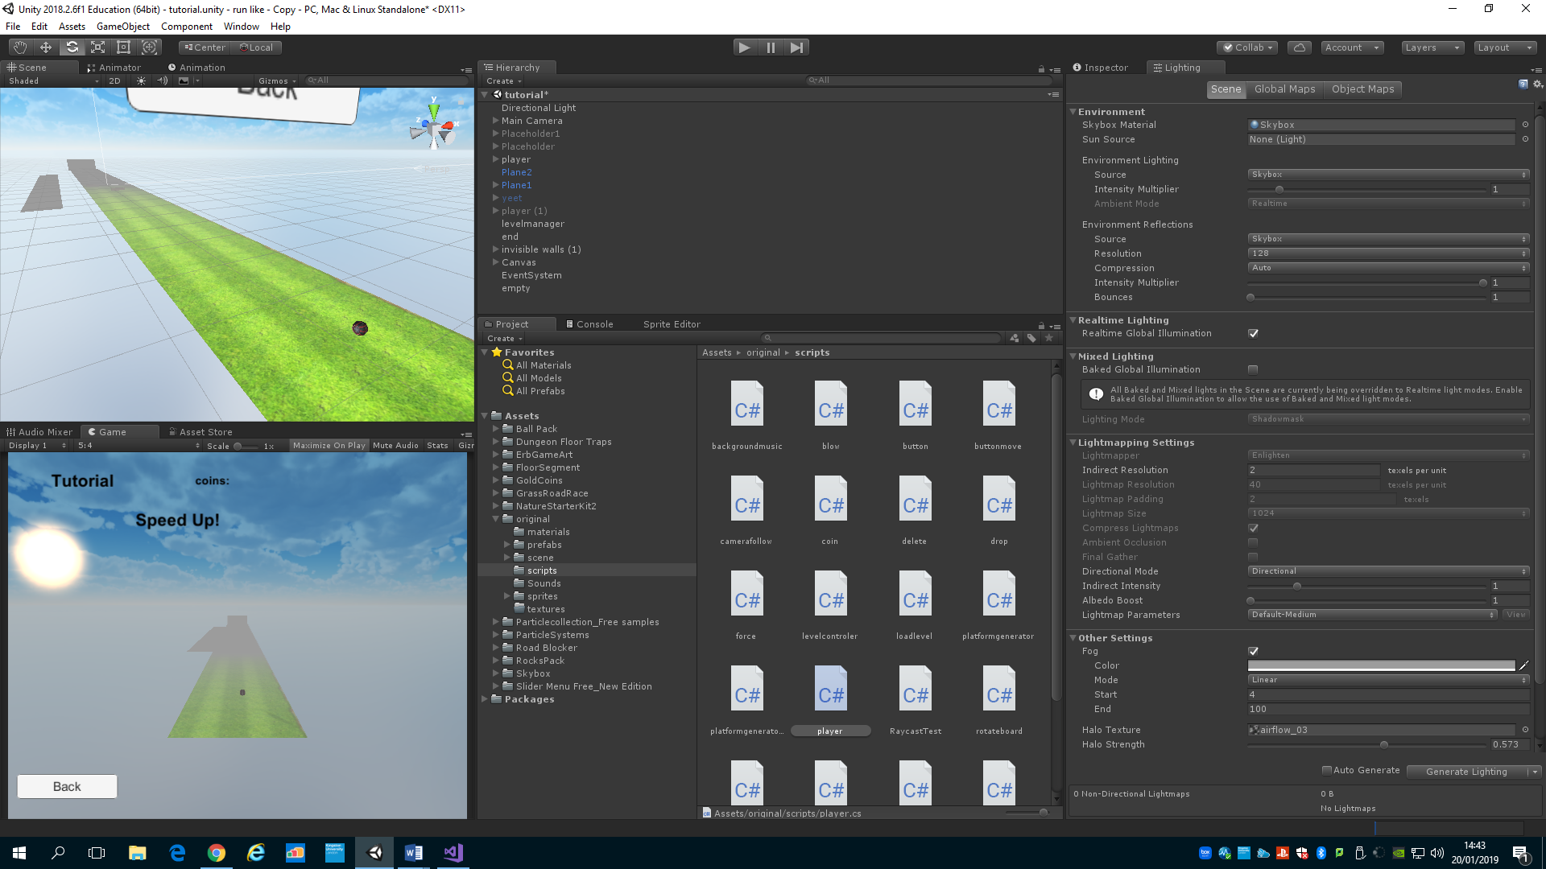

The board object is a simple stretched out cube with a tillable texture applied from the assets store. It tiles correctly and doesn’t look stretched out.

Powerups

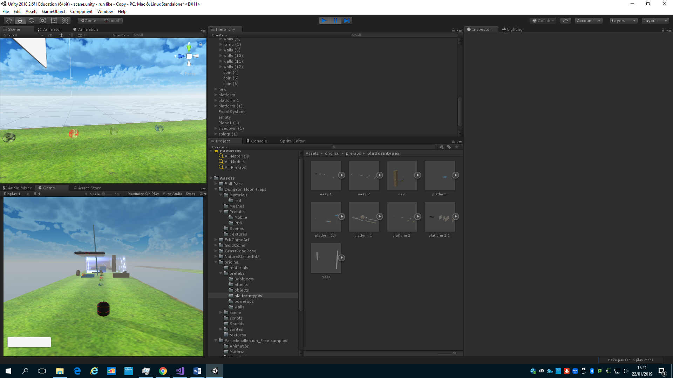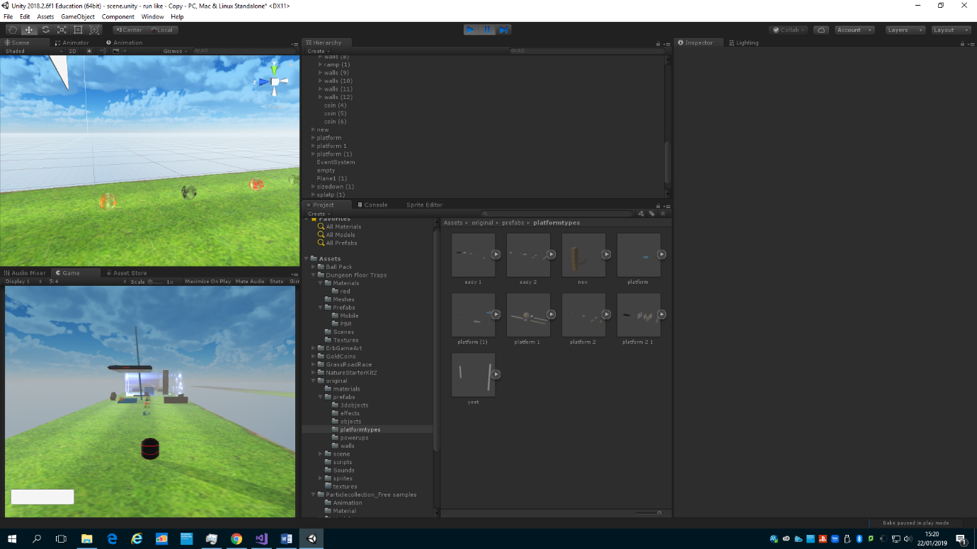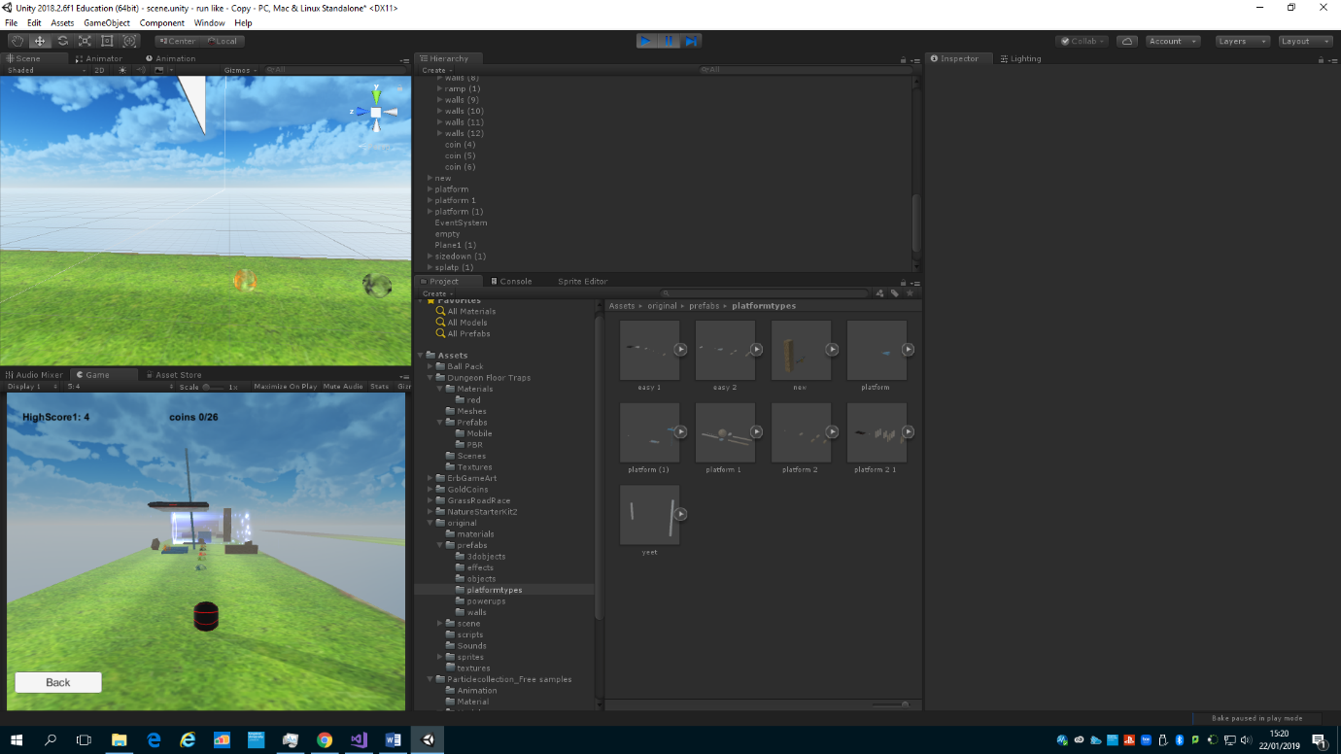

Each power up has a different feature, the yellow one makes the player big, the black one pushes coins away from the player, the red makes the player smaller, the green splats the players screen with goo and the blue attracts coins towards you. There visual design is an animated texture that gives the ball an active effect that makes it easily recognisable as a powerup.

Walls

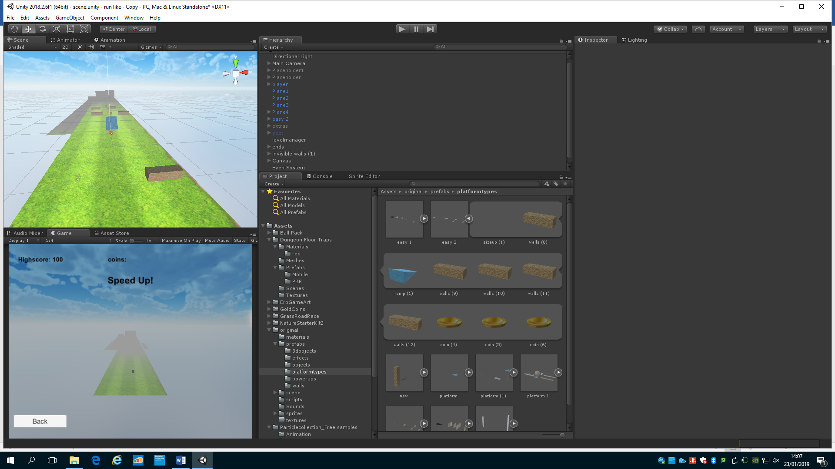

The wall has a simple wooden texture on it but in the tutorial the player is told to avoid that type of object. To keep level design simple every bad block has that texture.

Ramp

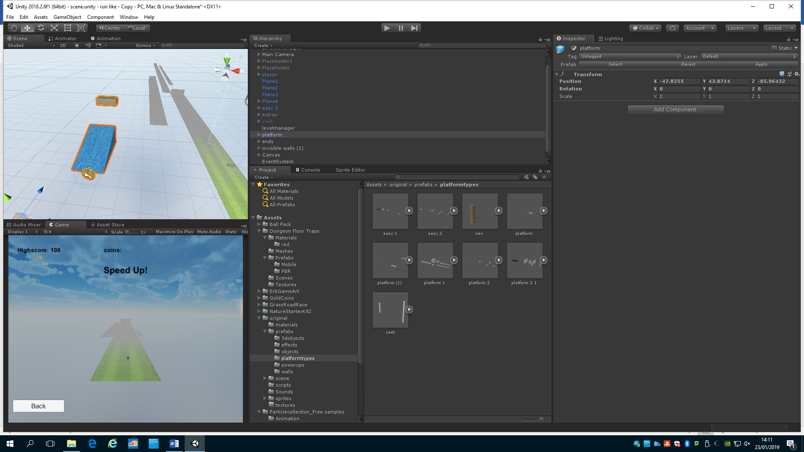

I created the ramp object in 3ds max, I stretched two points of the cube I created to make a ramp shape and then applied the blue texture to tell the player that this object is safe to touch.

Coin

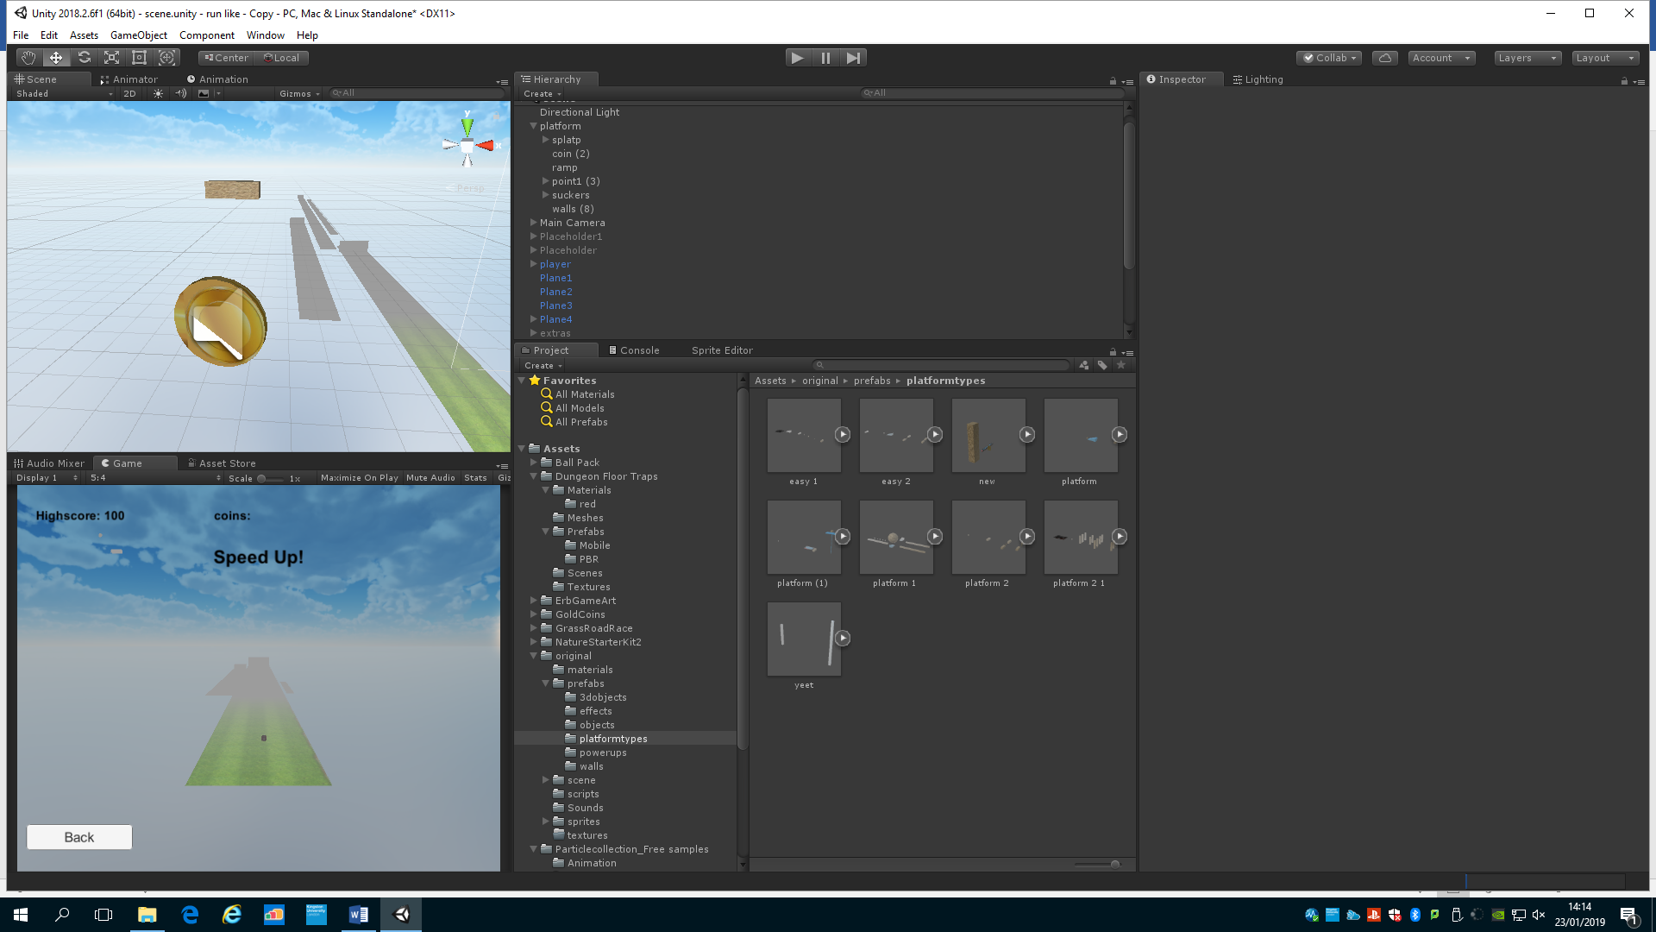

The coin object is a stretched cylinder with a downloaded material applied to it. The coin also rotates on a point.

Boulder

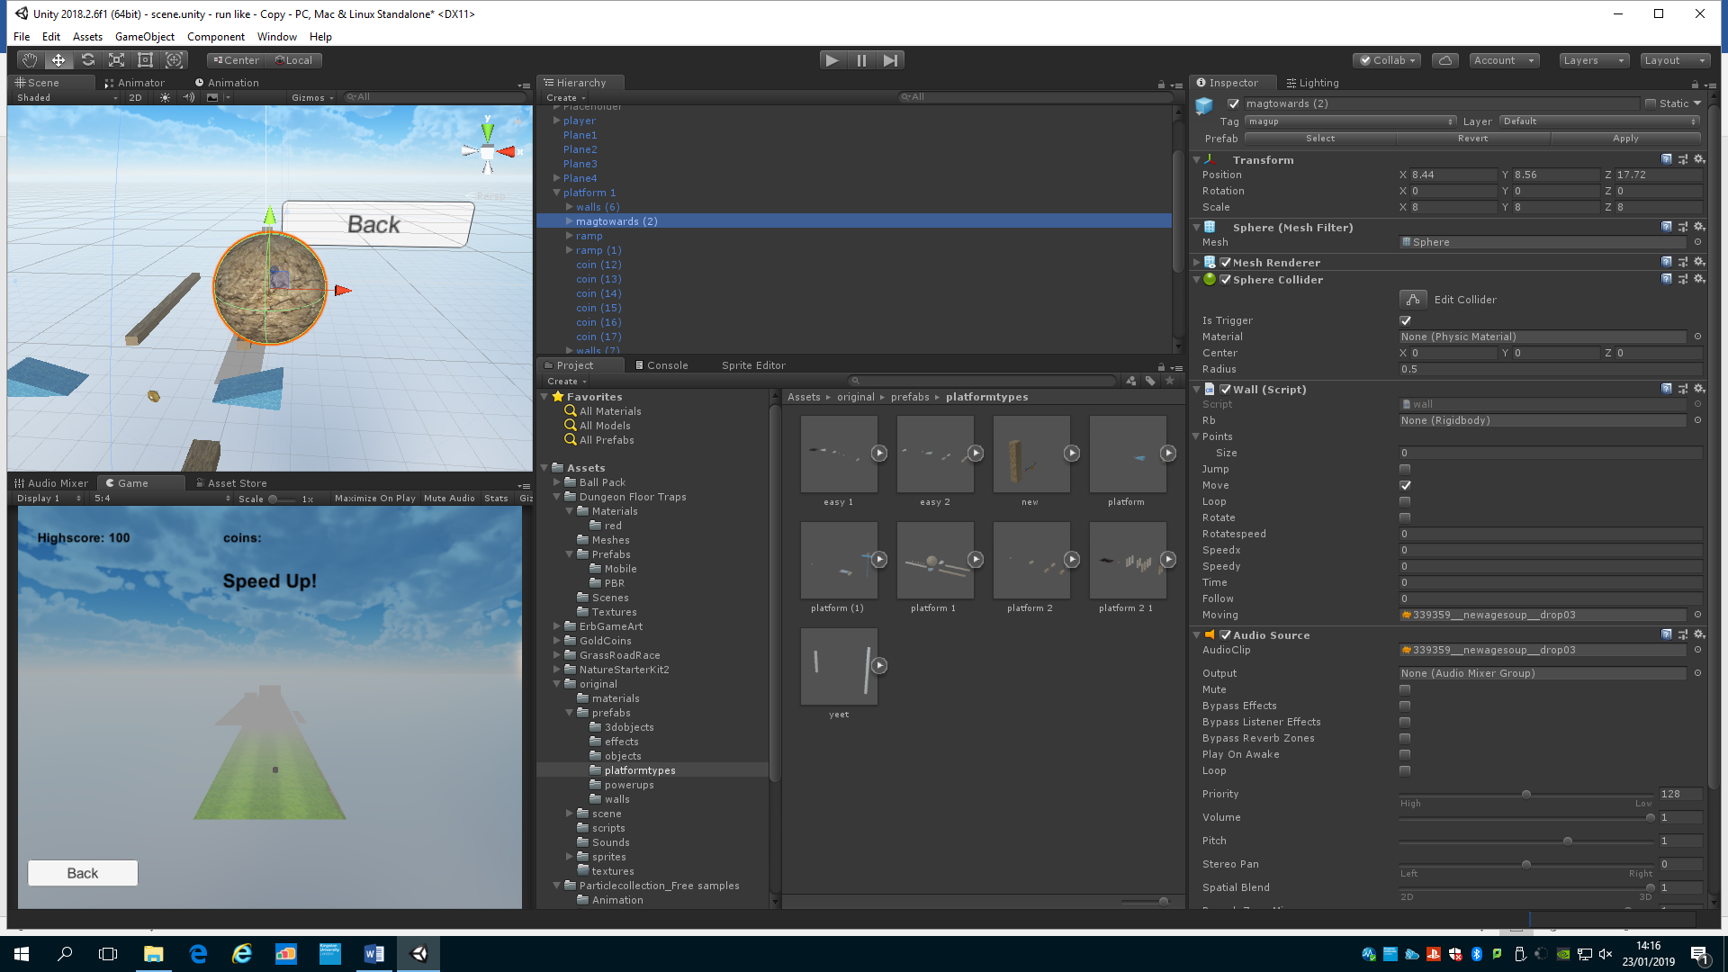

The boulder is a large sphere scaled up and has the wall texture applied to it to show the player danger.

Portal

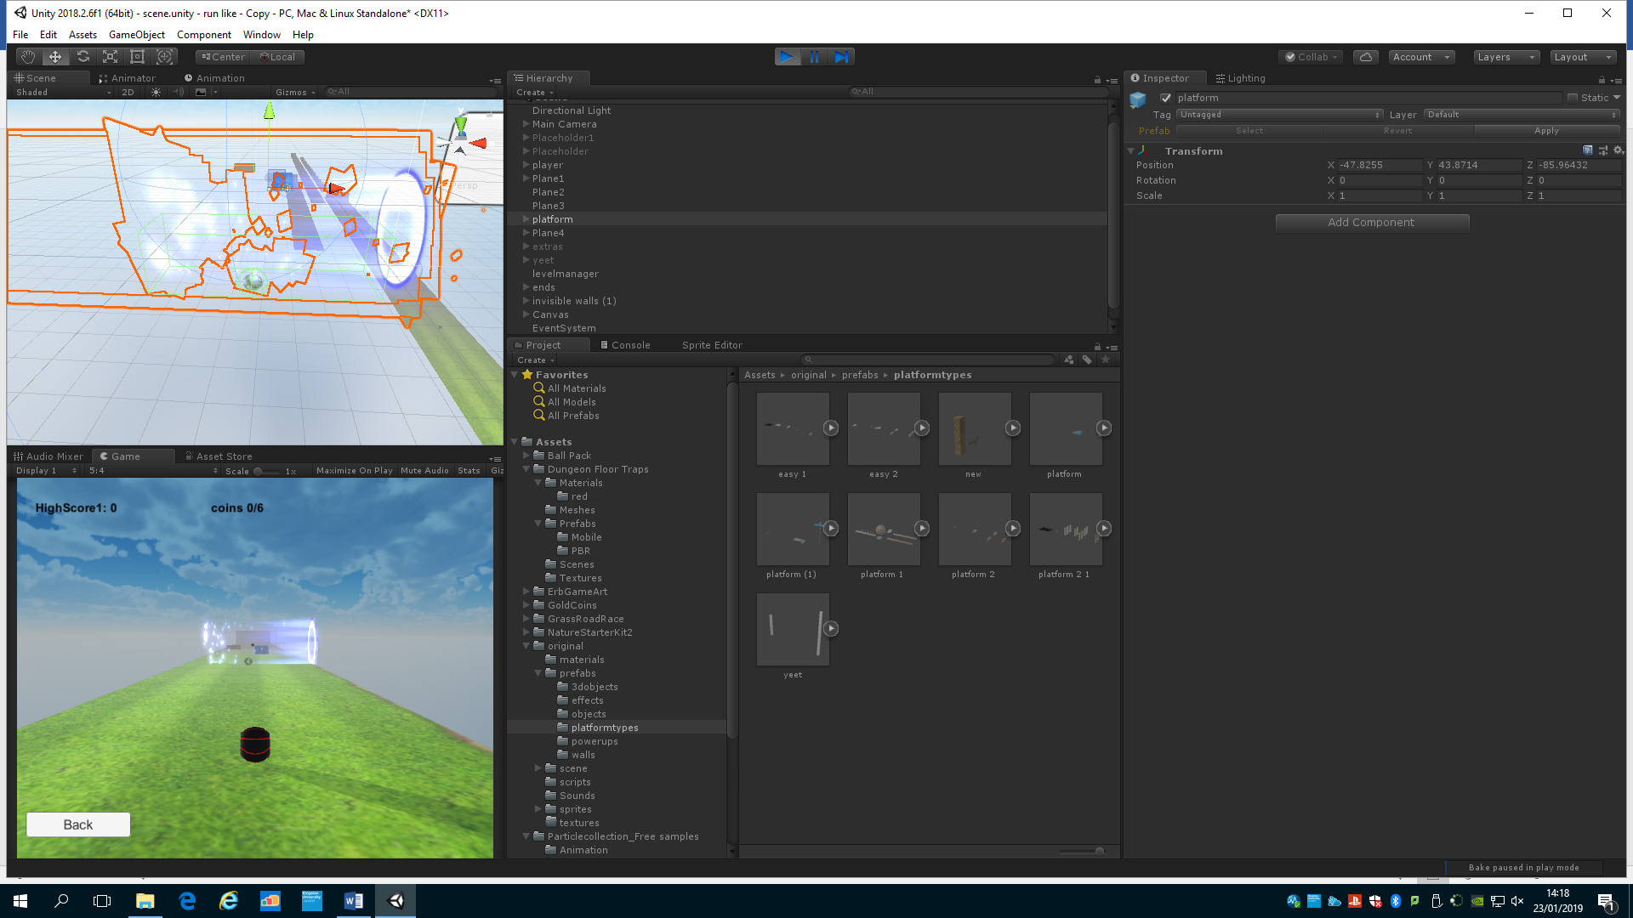

The portal is a downloaded prefab that pulls particles into the void and shows that it will moved the player towards the void, the light is very bright and can be seen from a far distance.

Blower

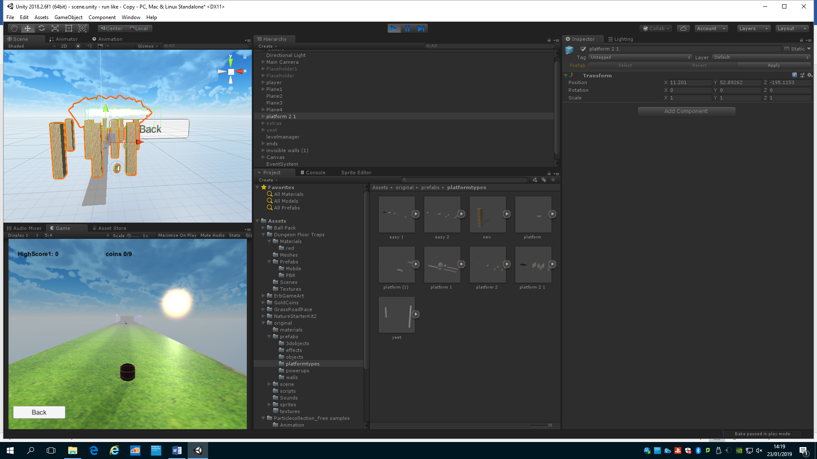

The blower just reduces the player vision on objects up ahead, it is a downloaded prfab that uses the particles effect to make smoke.

Button

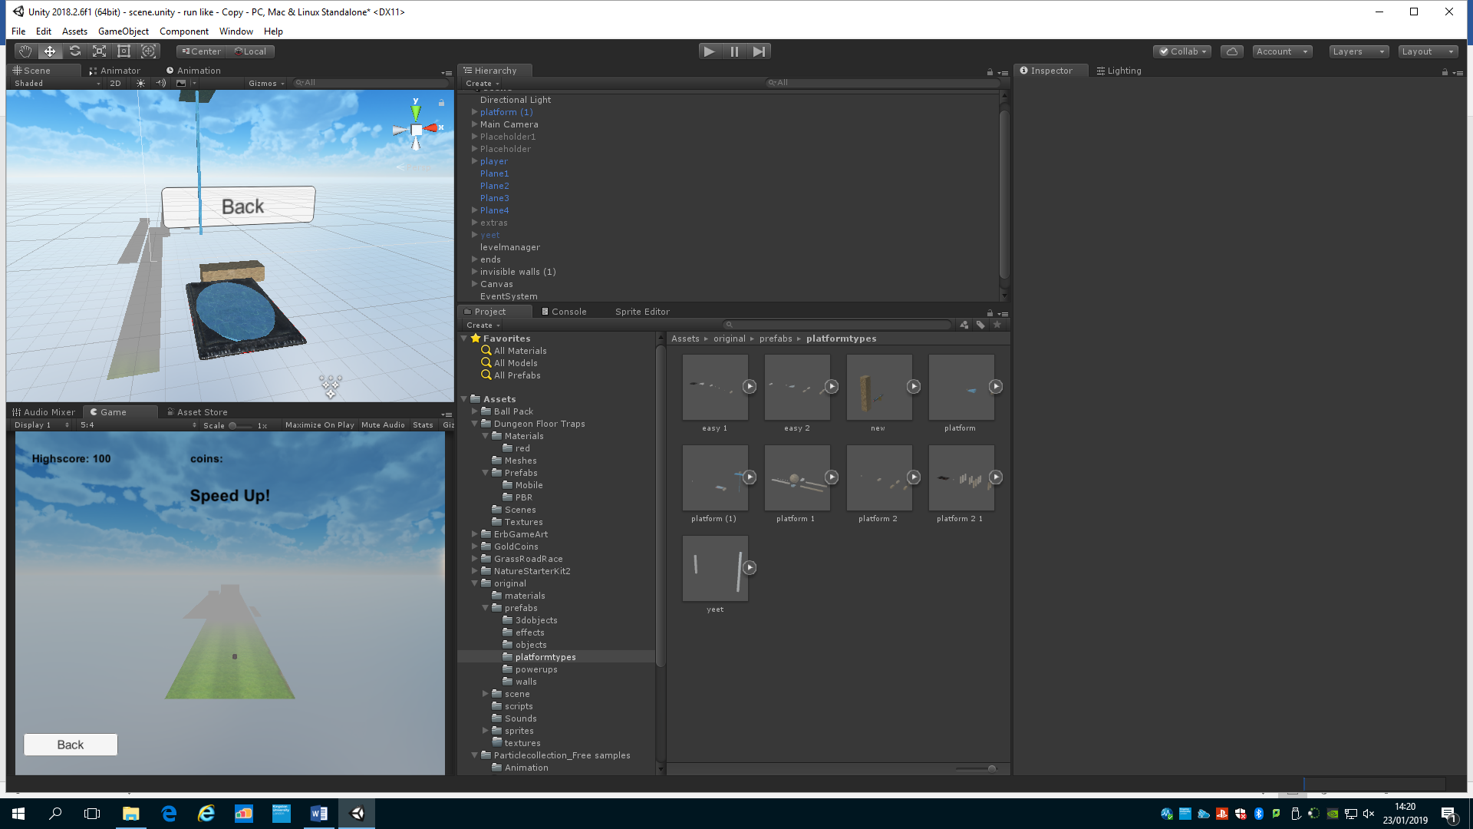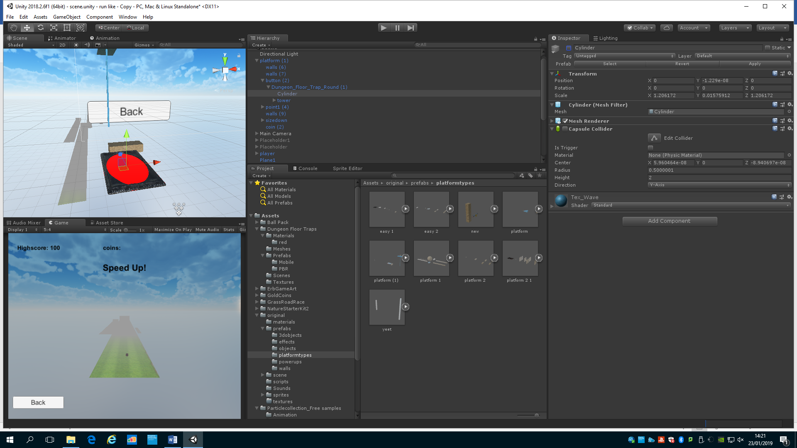

The button is a clear pad and once pressed the button will change to red showing it had been activated. This is a downloaded prefab and has a simple cylinder child object to change the colour.

Speedup/down

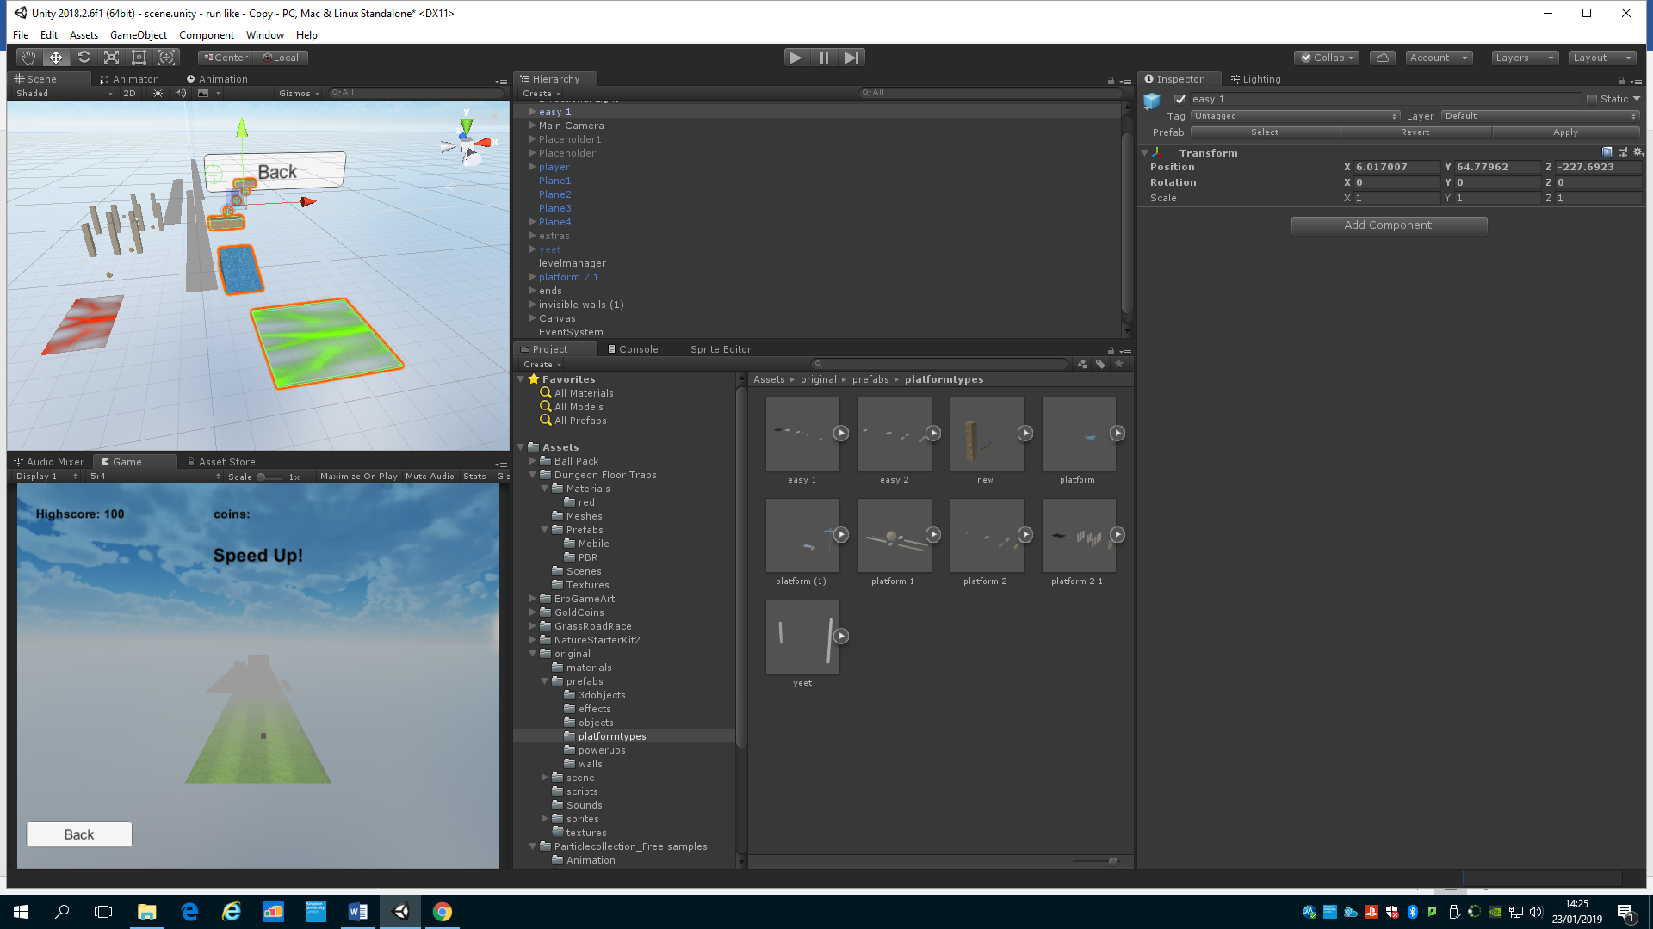

These pads have the same effect as the powerups which tells the player activating them will change something. The green one is to speed up and the red is to speed down.

UI

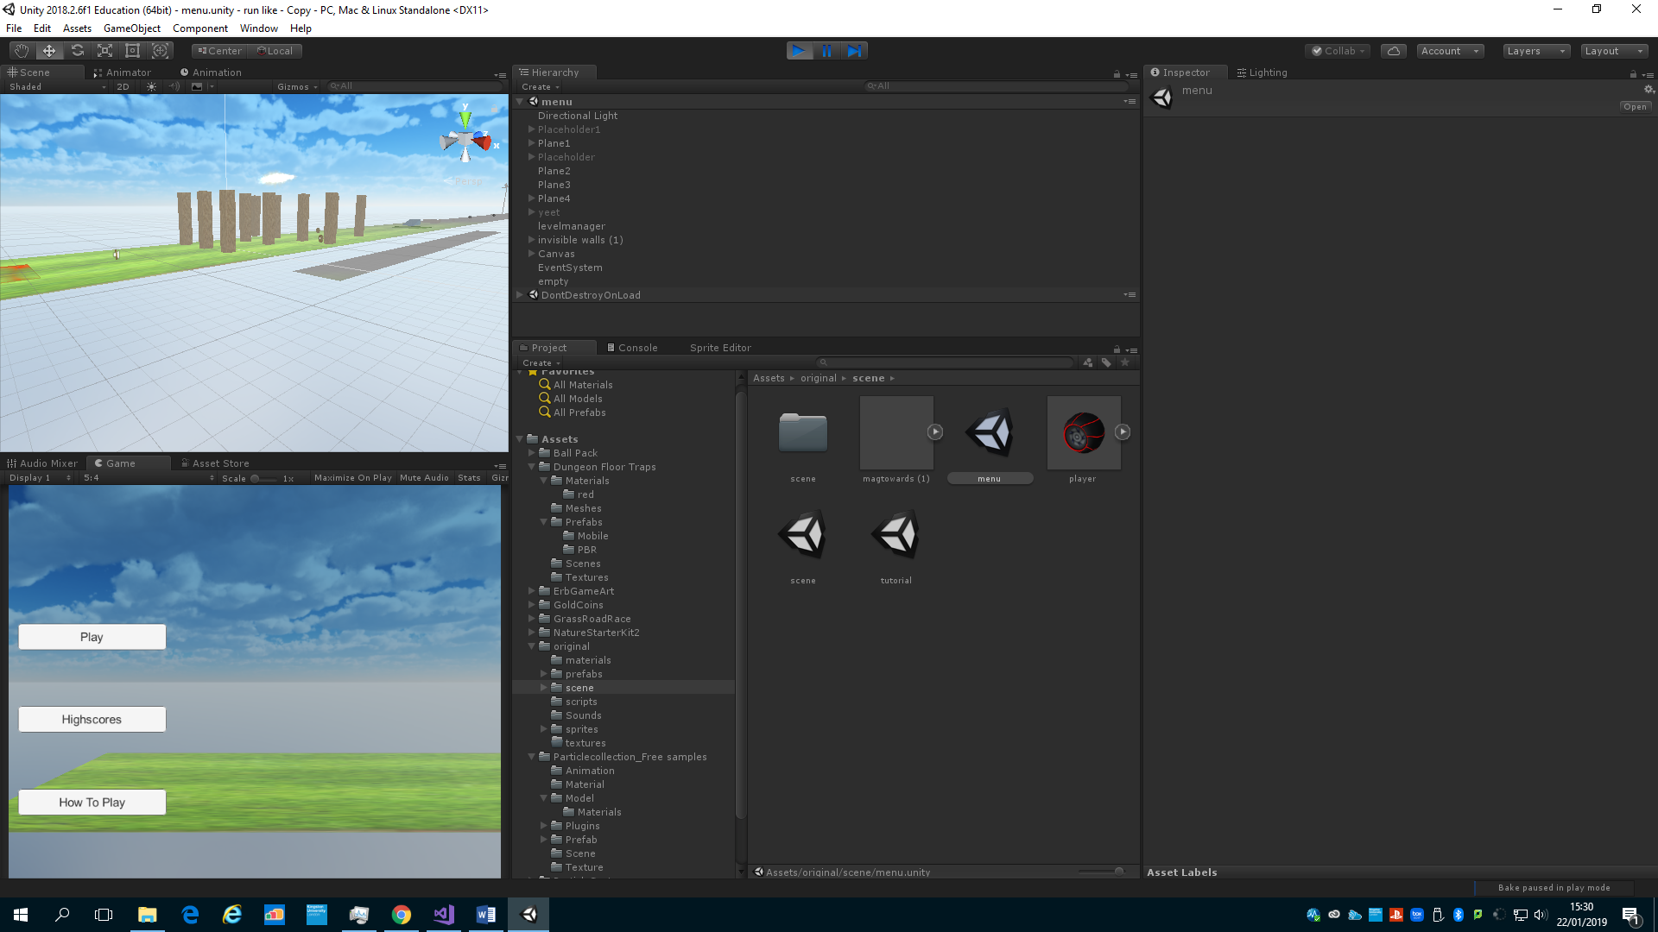

The main menu features a button system, that when pressed it will preform certain tasks, for example pressing play will go to the scene where the player plays the game. This is created by using the button UI system, which is part of unity’s game engine. Part of the UI also features text which is the default text and shows the players values.

Obstacles prefabs

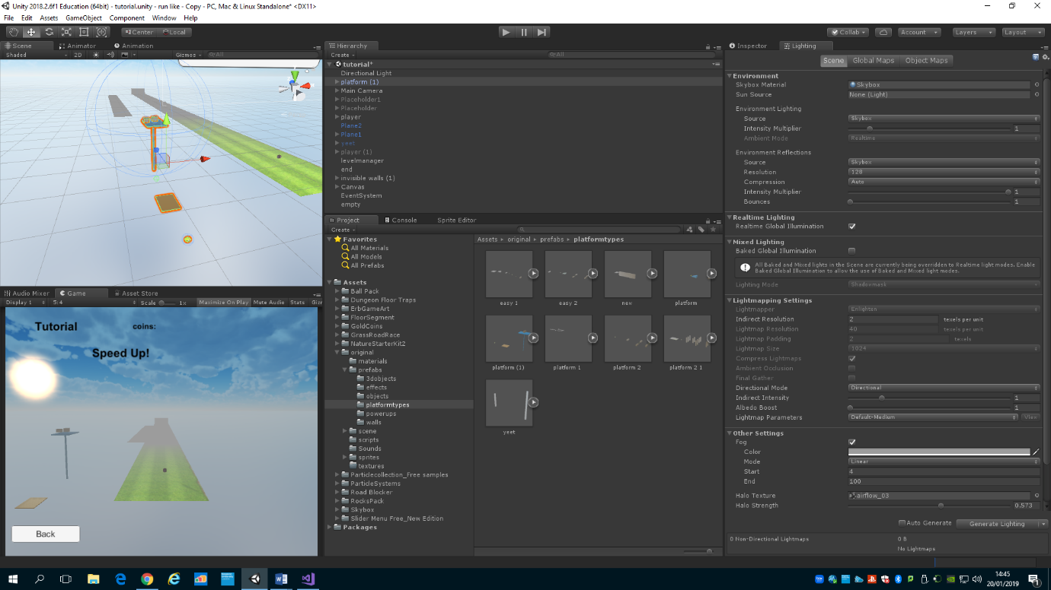



All the obstacles are part of separate prefabs that are randomly generated, the different obejcts types are; coin, wall(stationary and moving), powerupsmagnetup, powerupmagentdown, powerupsizeup, powerupsizedown, poweruplevelchange, powerupfaster, powerupslower, pullportal, blower, bolder, button, points (empty gameobjects to control walls precisely and easily), and ramp.

The materials used for all these object arte from the unity store.

Most of these objects are just cylinders or cubes scaled correctly and applied with a certain material, the cube I made in 3ds max and just stretched two of the cubes points to make it a ramp.

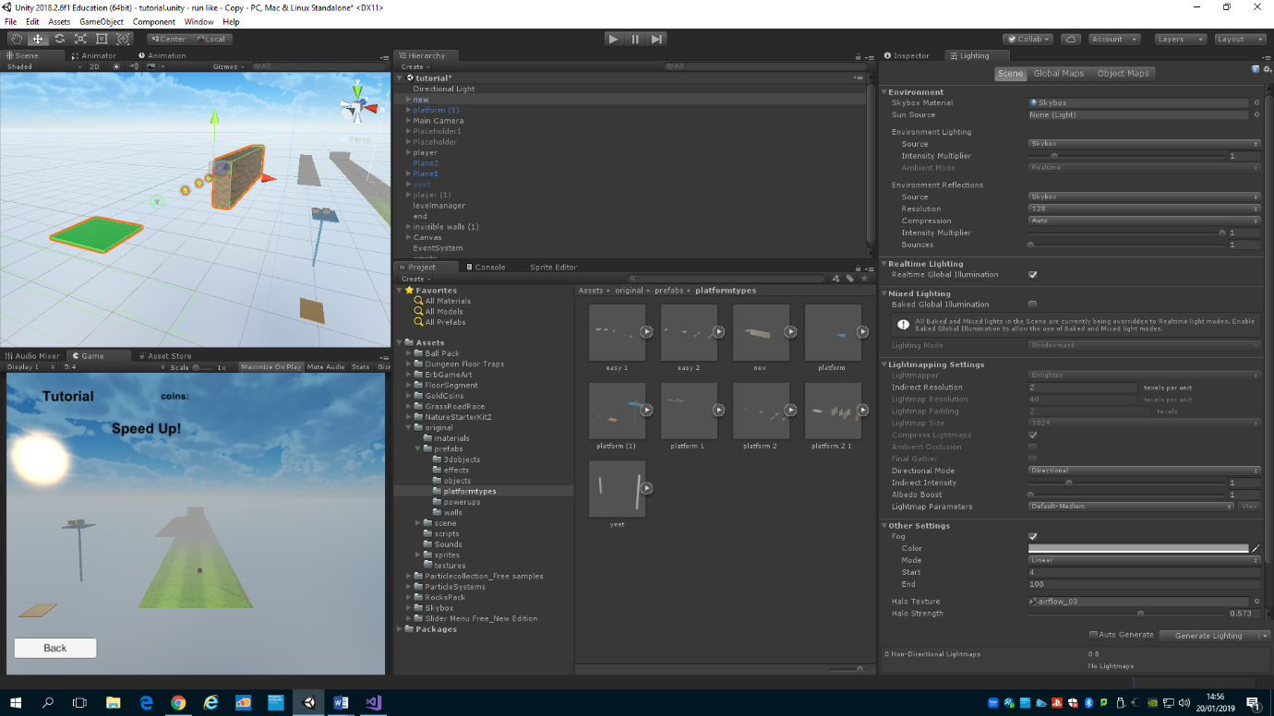

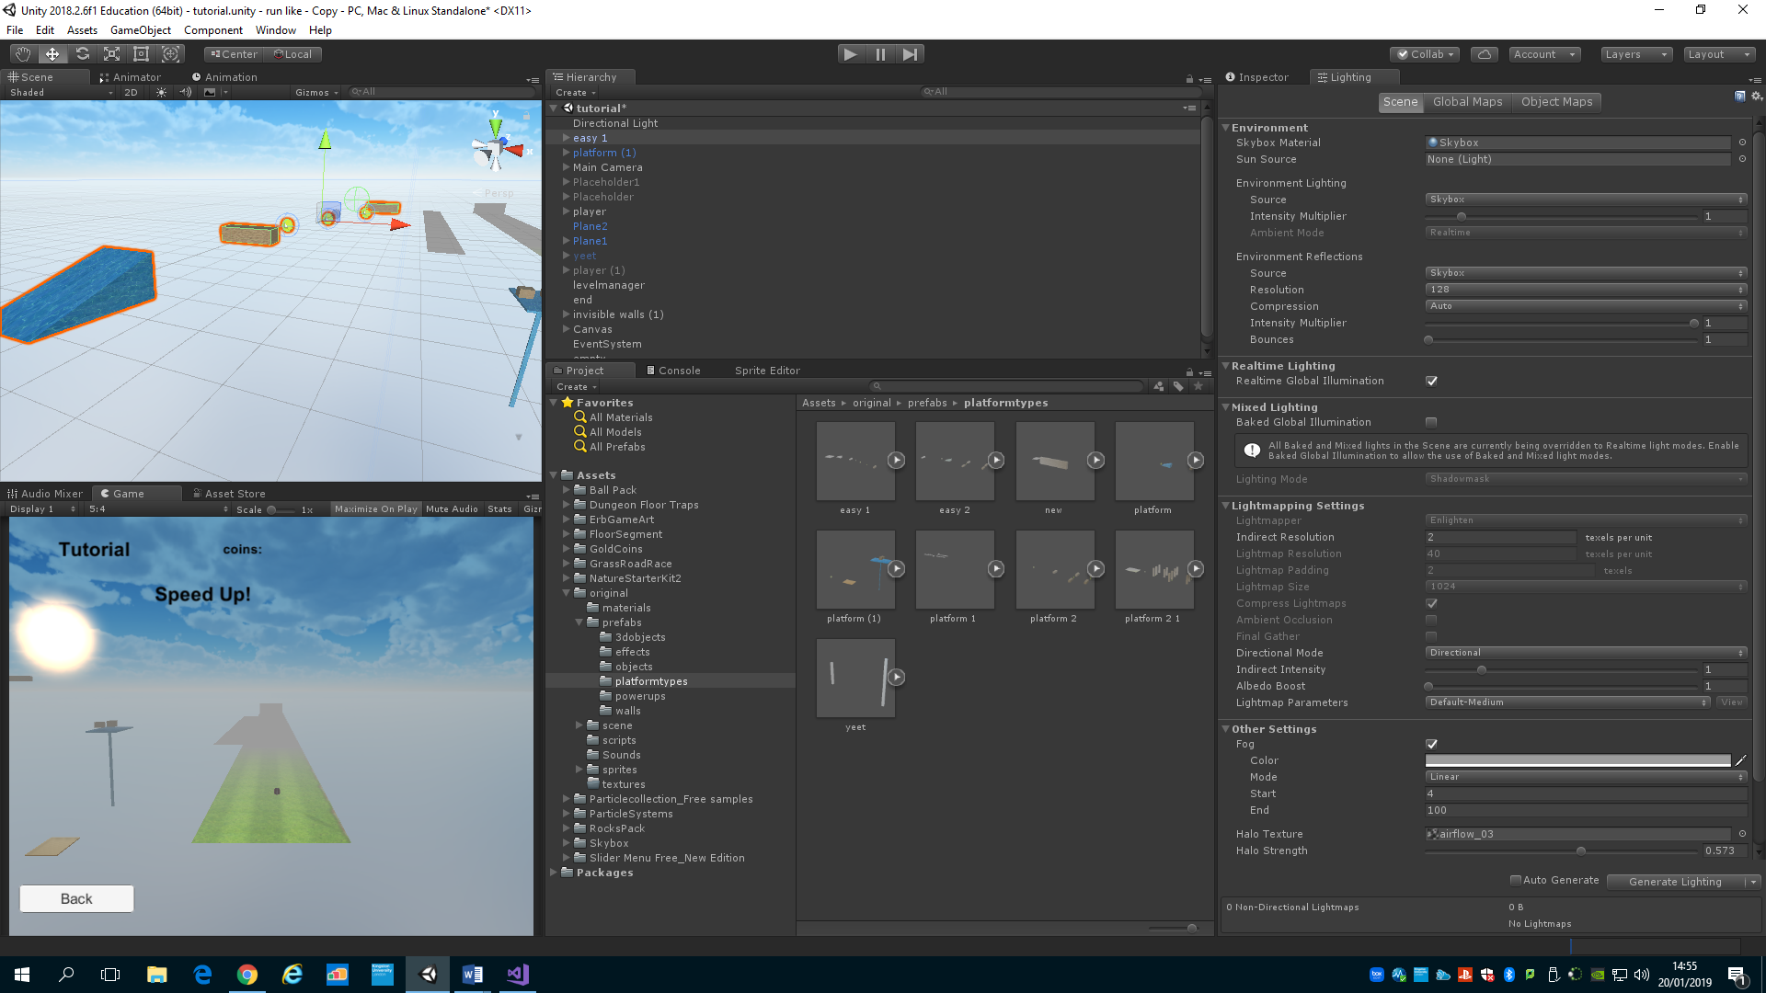 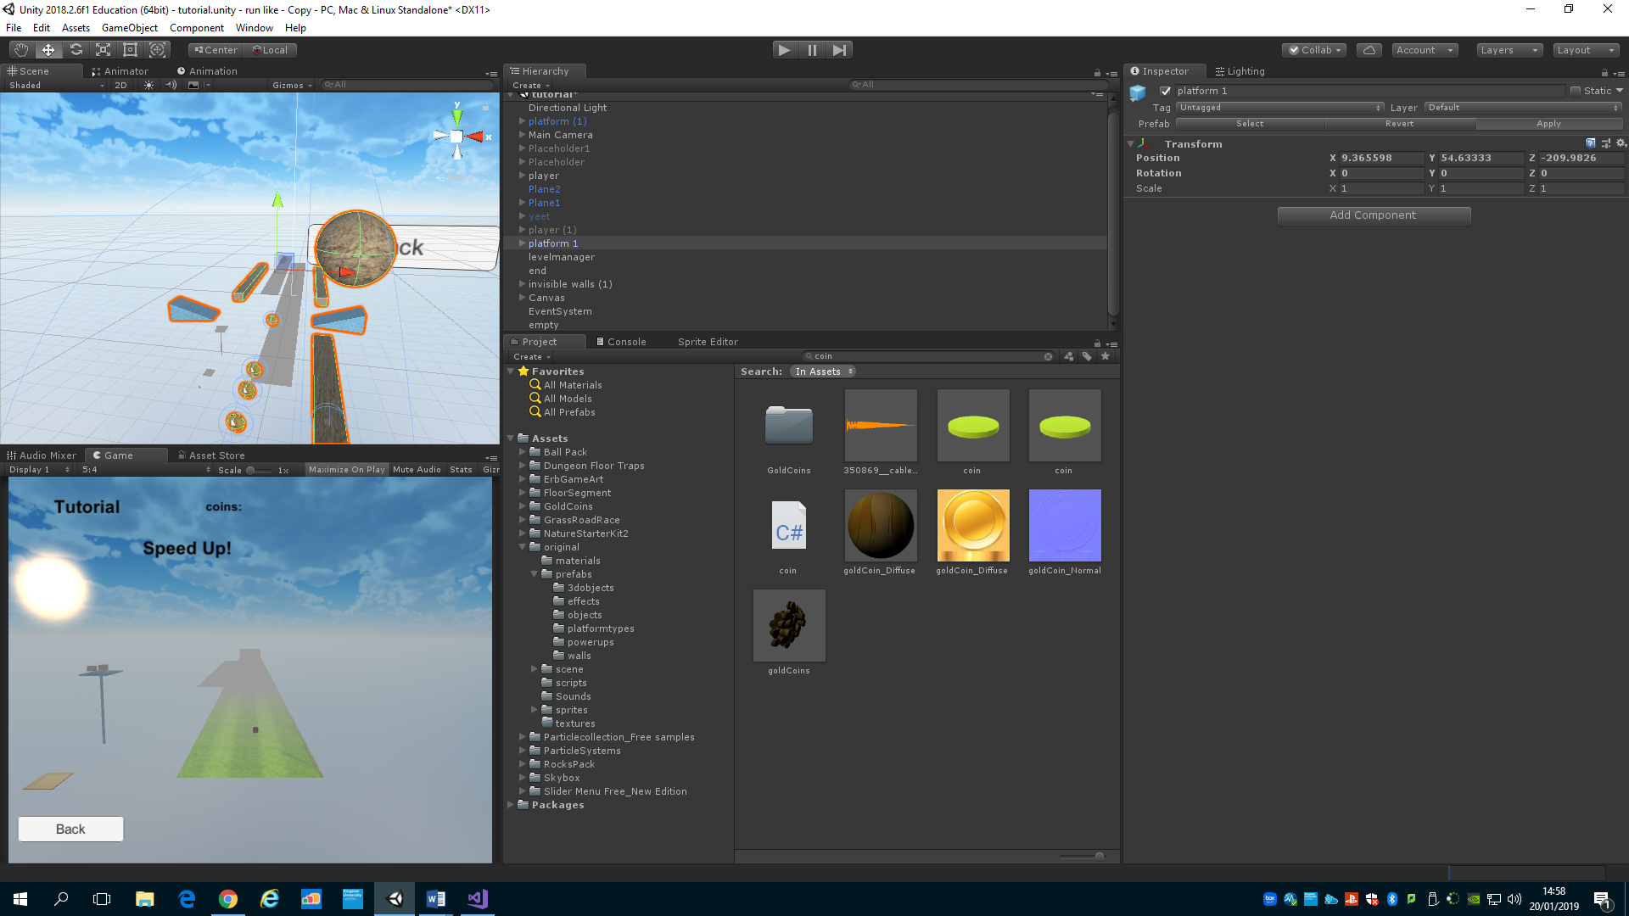 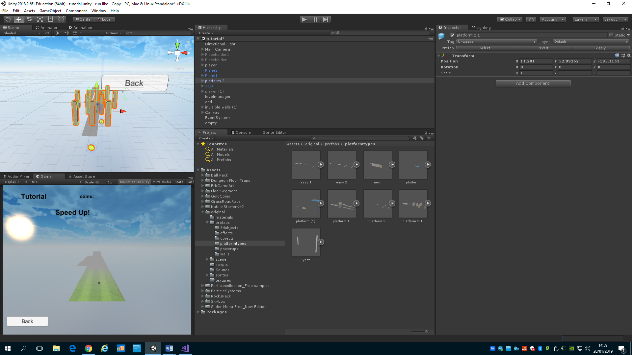

Links to assets in unity store:

<https://assetstore.unity.com/packages/3d/props/ball-pack-446>

<https://assetstore.unity.com/packages/3d/props/interior/dungeon-floor-traps-77765>

<https://assetstore.unity.com/packages/vfx/particles/spells/aoe-magic-spells-vol-1-133012>

<https://assetstore.unity.com/packages/3d/props/gold-coins-1810>

<https://assetstore.unity.com/packages/3d/environments/roadways/grass-road-race-46974>

<https://assetstore.unity.com/packages/3d/environments/nature-starter-kit-2-52977>

<https://assetstore.unity.com/packages/vfx/particles/particle-collection-skj-2016-free-samples-72399>

<https://assetstore.unity.com/packages/3d/environments/5-rocks-package-133702>

<https://assetstore.unity.com/packages/2d/textures-materials/sky/skybox-4183>

Skybox

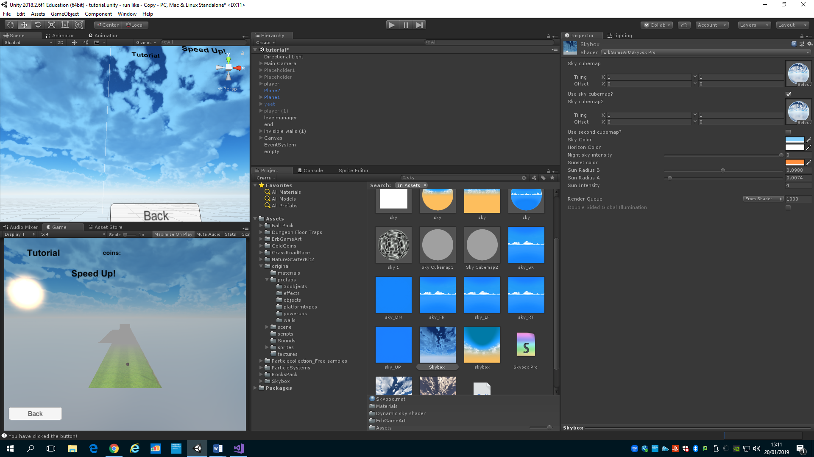

The skybox is a texture that is put on a cubemap witch goes in the lighting window. This goes across the whole game background.

Technical Design

This is a little diagram showing all the main scripts and how they relate to one another and what data they hold.

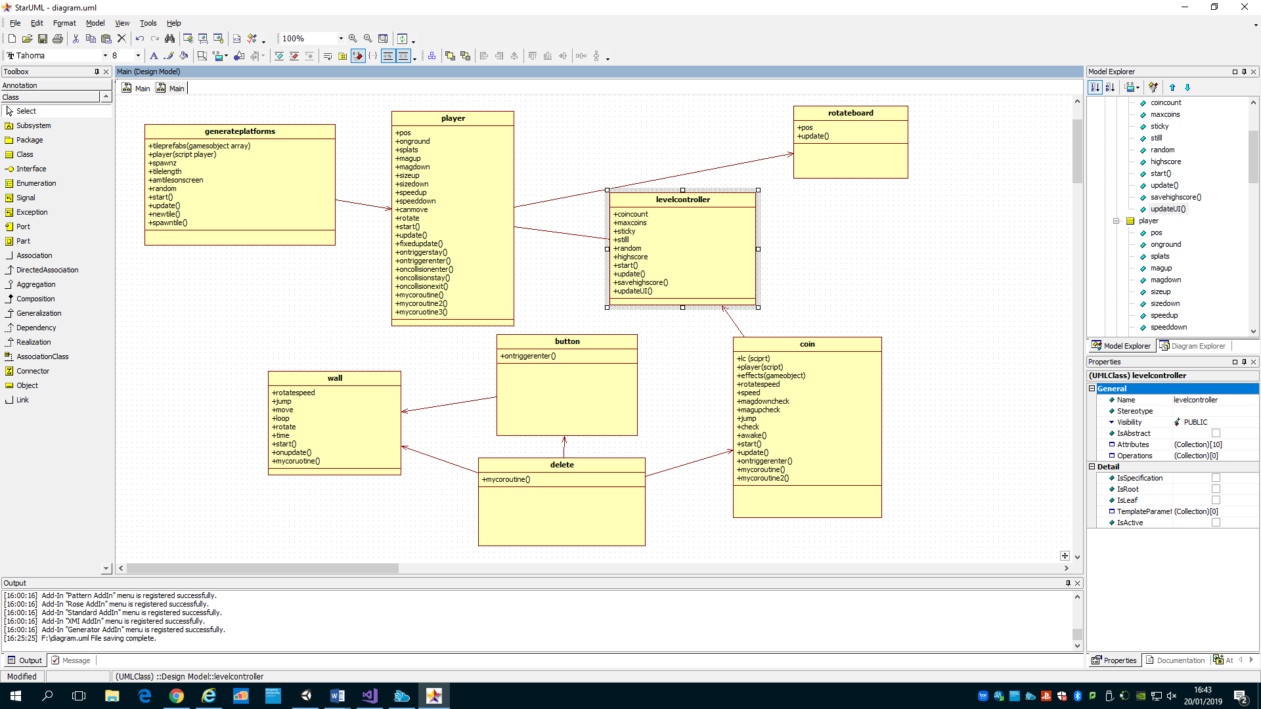

Player and levelcontroller are the most important script and hold most of the functionality, player holds all the interaction involving the player such as movement collision with other gameobjects and sound. Player uses the rotateboard script to get the angle of the board to add positive or negative force to the x axis of the player. In the rotateboard script it also says if no key is pressed multiply the force to give that rolldown force effect. Player also holds all the collision detection for powerups and can directly change its size, speed or other variable and destroy the other gameobject. Levelcontroller holds all the general information such as score, highscore and world changes, certain scripts link to each other to get and set different variable and methods.

The random generation script generates 7 platforms infront of the player with given distances, when the player has 6 in front of them it will create a 7th with the given distance in front of the 6th. It randomly picks a platform from the list of gameobbjects. Each boards has certain difficulty platforms.

Some scripts like the wall script is set out to be used as a moving tile or a stationary one. It uses speed to determine how fast it moves from point A to point B and time to tell it how long to wait before moving back. This allows me to set different values in the inspector for different gameobjects using the same script.

Most of the variables and methods are public as they need to be accessed from other scripts.

There are many scripts each with a different purposes, they could be as complex as player or as simple as just rotating the light every frame. I have tried to use the best optimised way to add these features.

Implementation-----------

How you implemented the game. Include a selection of code extracts and describe what they do for the most interesting parts of your implementation.

Include in your discussion comments on how you implemented the following (where appropriate) and other relevant aspects of your implementation.

Behaviours: Actions the objects can perform or the player can perform on the object (if any)

Relationships: How the objects affect each other and interact with the player (if any)

Dynamics: Explain how C# code is controlling the dynamic behaviour of each graphics object.

Collision Detection: Explain how the collision detection is implemented

Here I will show how I made my game with all the important steps and explanation of scripts.

playermovement

I started with player movement, which was later changed. First I added force to the player by adding and subtracting depending on the left or right button, but this wasn’t quite accurate and I went down a different route to find the movement.

I used script reference to link to the rotate board script.

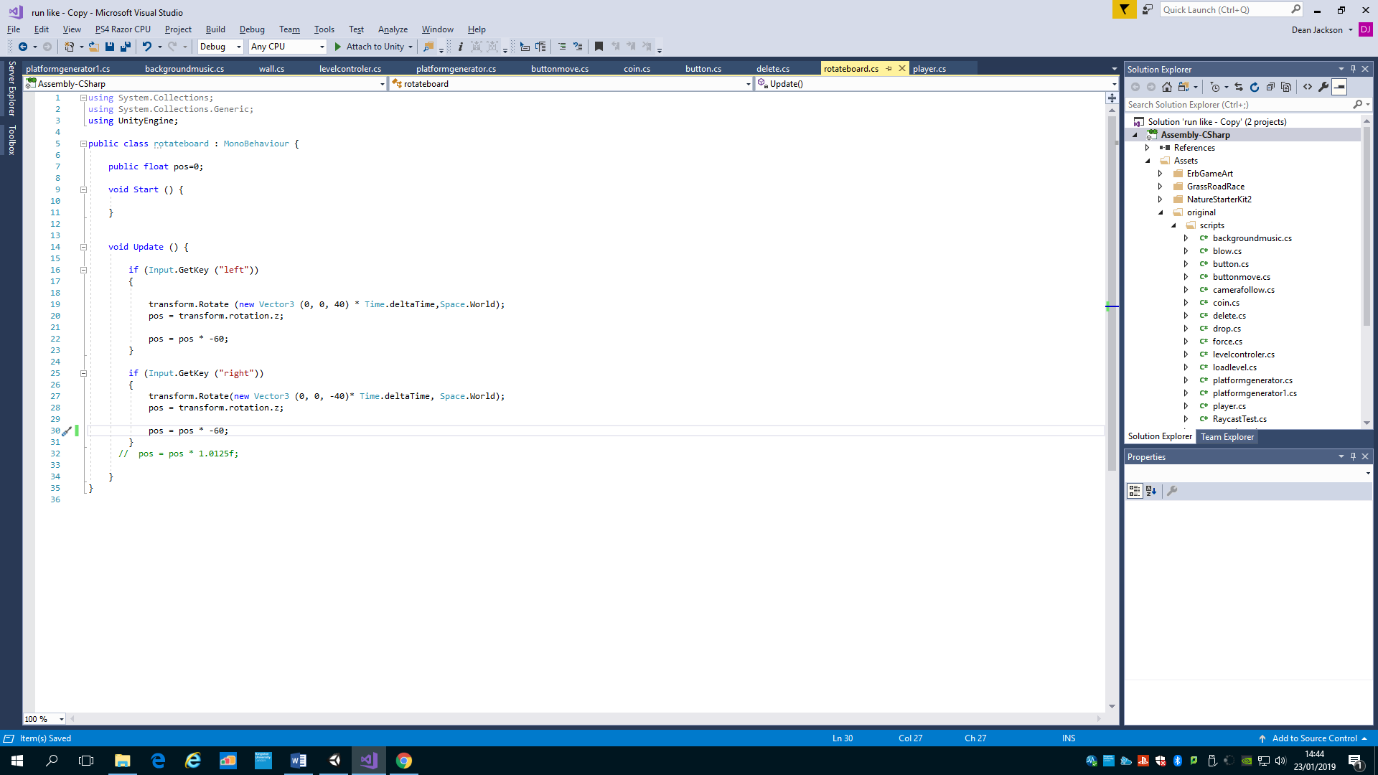

Similar to left, but with right key and negative 40.

If the player presses left, rotate the board by 40 on the z axis and made avarible of position equal the value of the board.

In the player script the player uses the pos variable to determine the amount of force needed for the movement.

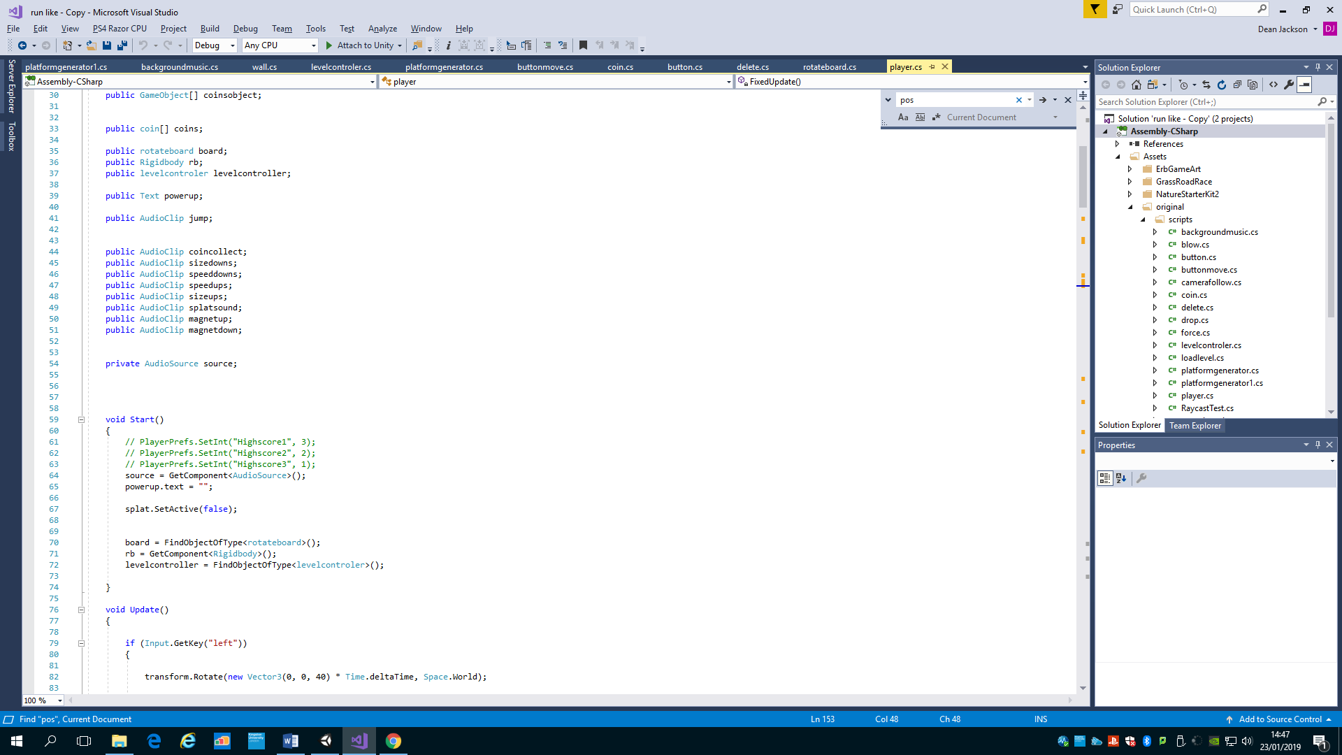

This references the right script.

This finds the script

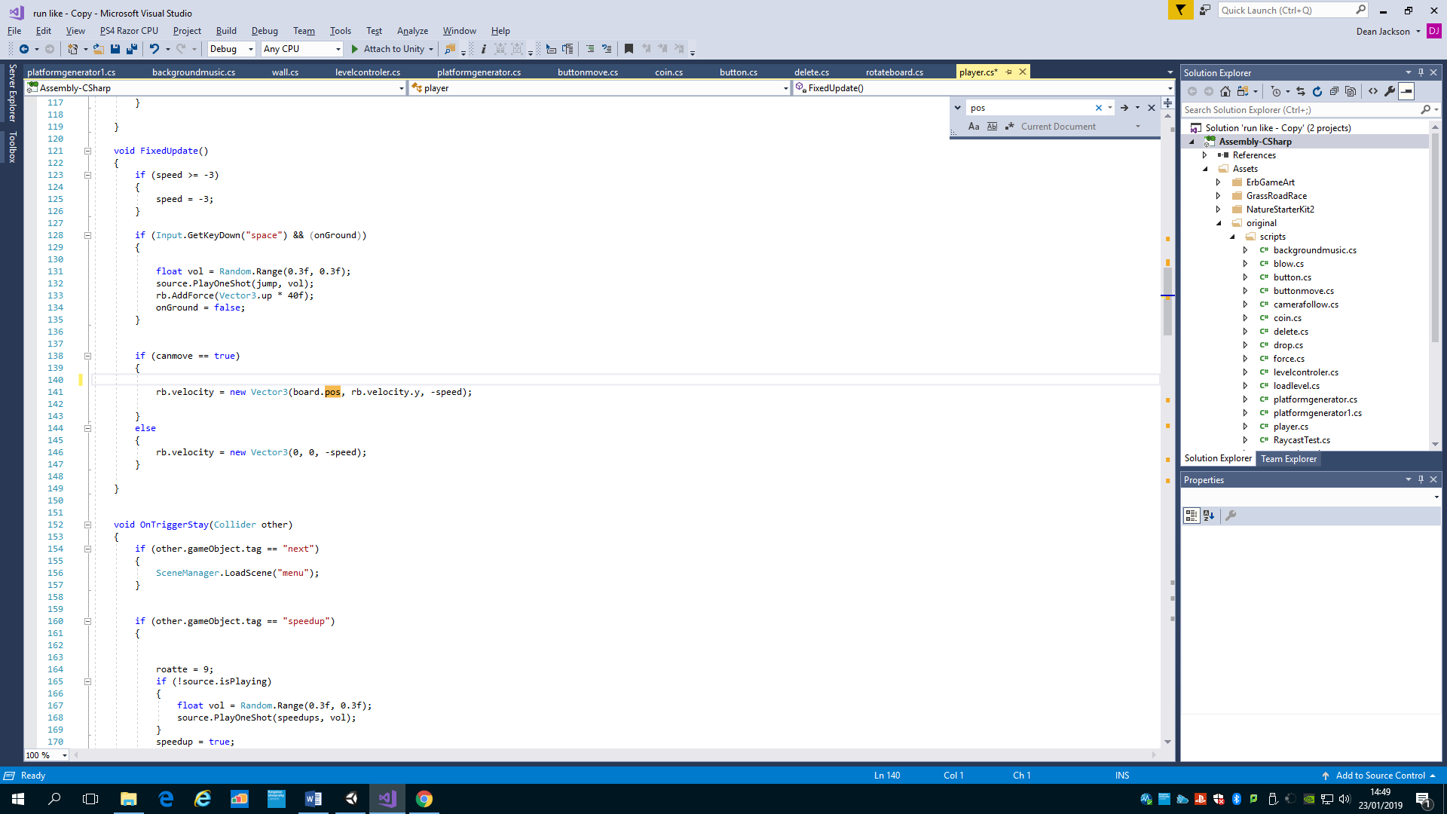

This makes the player move on the x axis by the pos value in the board.

This is a lot more accurate as it gets the rotation straight from the board and has no chance to go off course.

This makes the player rotate by 40 on the z axis to give it the tilt impression.

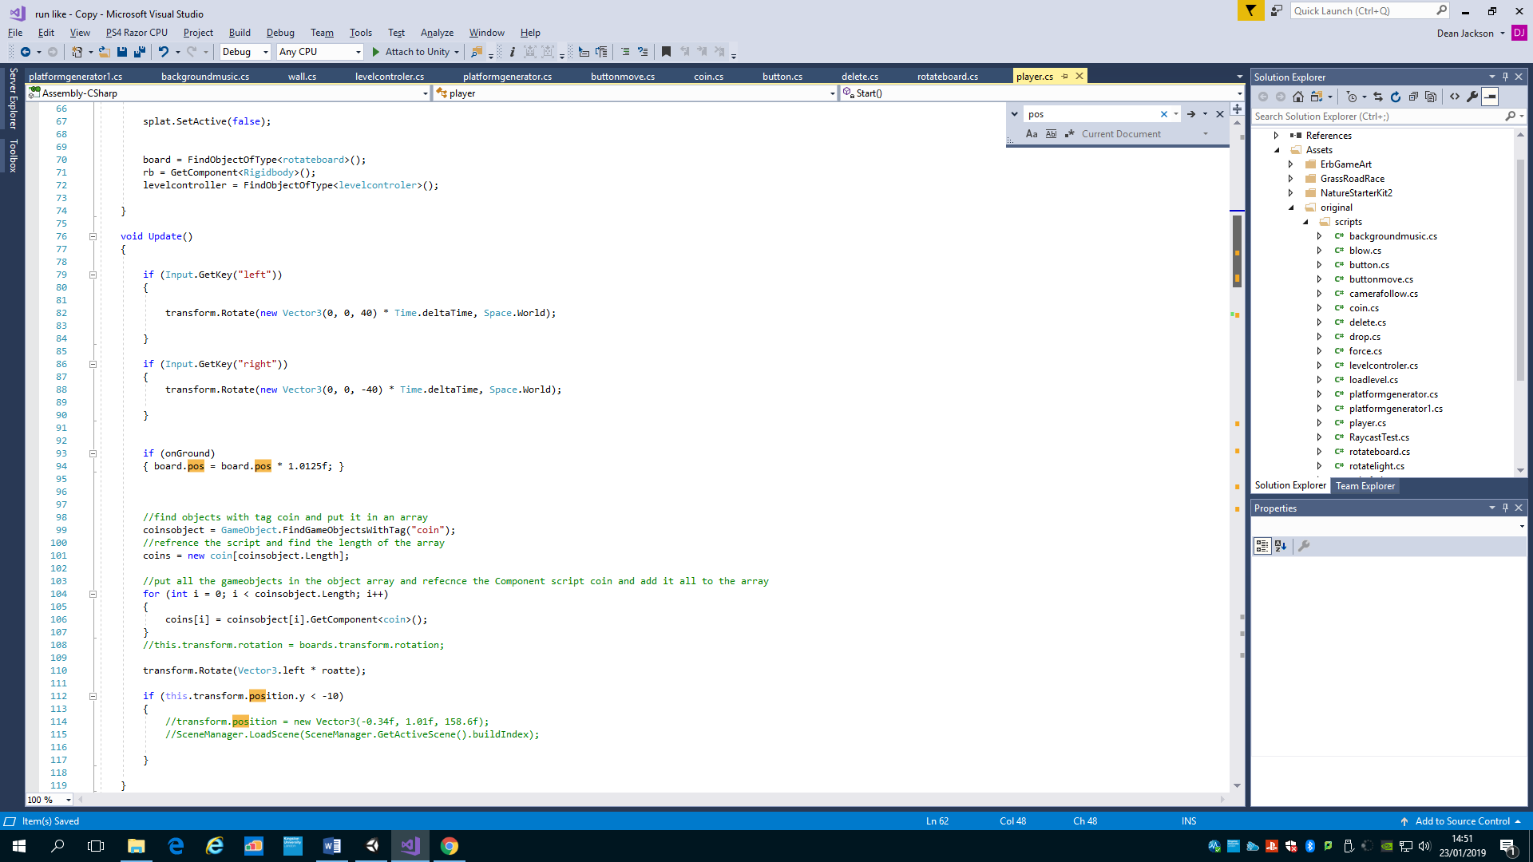

This makes the player rotate by 40 on the z axis to give it the tilt impression.

This makes the player increase its force if no button is pressed, this gives the speed up roll off effect.

That is the main blocks of code for the players movement.

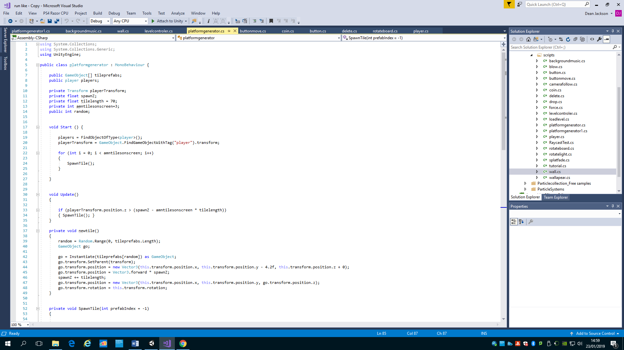Random generation

This checks if the amount of tiles on the screen is less that then the desired amount then spawn a new tile,

The newtile method holds all the code to create a random prefab from the array and places it in the correct position in front of the last object

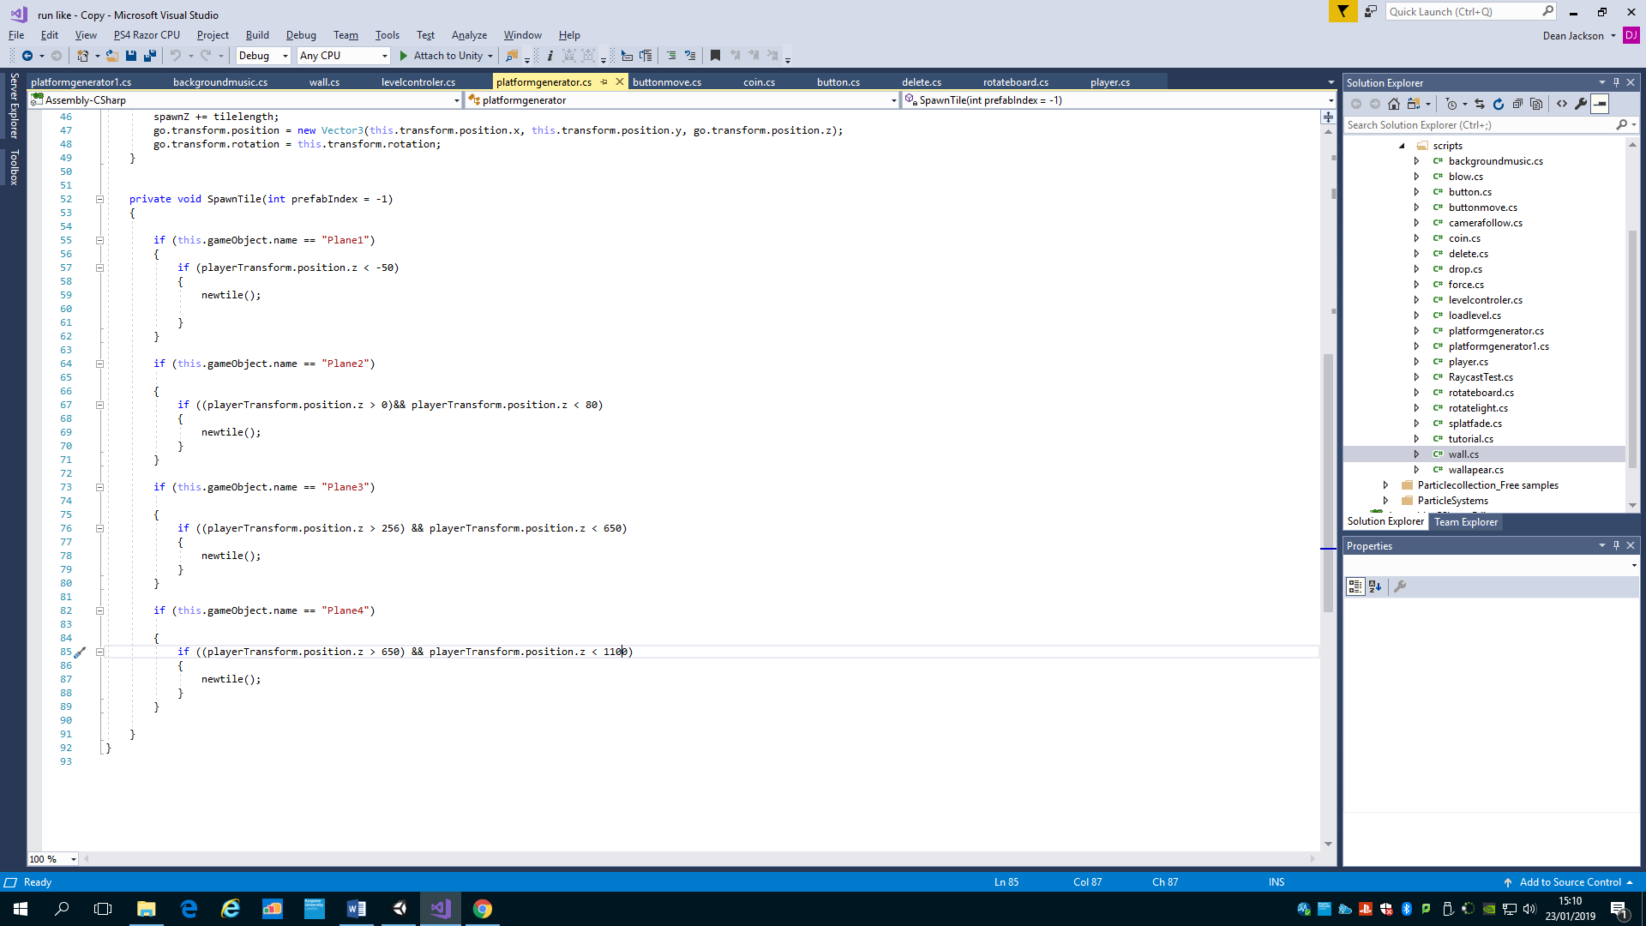

The script is attached to each plane and then checks to see which plane this gameobject is and then checks if the player is in a suitable range to spawn a new tile.

This makes random generation and in the inspector I can drag the correct gameobjects in the array that I want to spawn, this can be different for each object using the same script.

Coins

This makes the coin rotate evry frame in one direction. I added a constant movement mechanic for the coin but never used it, however I left it in the code.

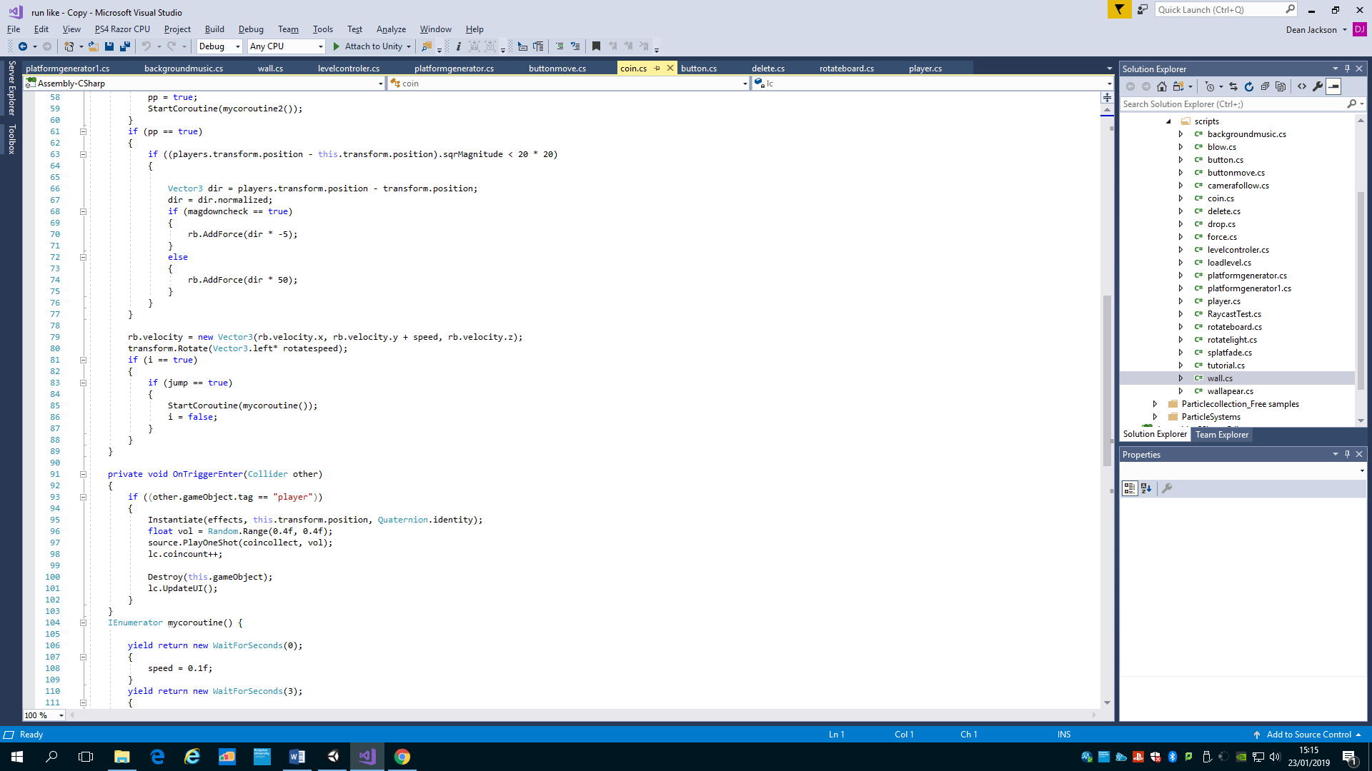

If the coin collides with player instantiate an effect and play a sound, increase the coins collected by 1 and destroy this gameoebject.

The coin script features basic mechanics for all coins, and later includes a powerup, which I will talk about later. I did include movement for the coin, similar to the walls but decided that coins should be static but left the code in.

Walls

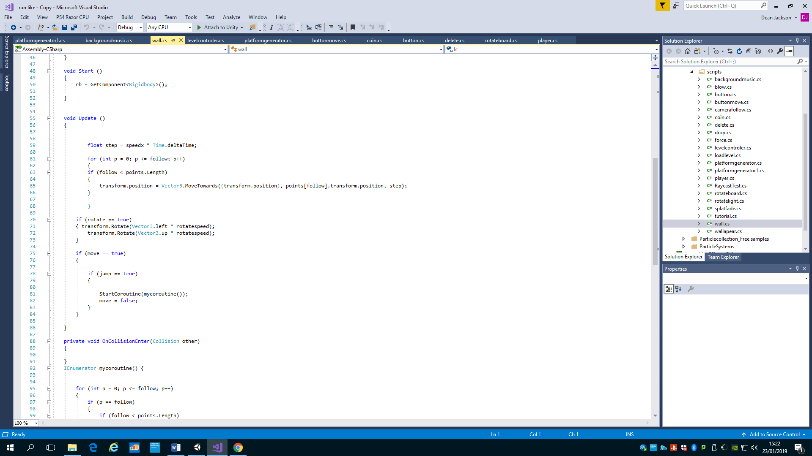

Move this gameobject towards the reference gameobject(s) point.

If in the inspector the jump and move button is true then start the coruotine, the coroutine changes the follow variable to increase and play the correct sound effect. The follow varibkle will then make the gameobject move on to the next point after the variable time has passed.

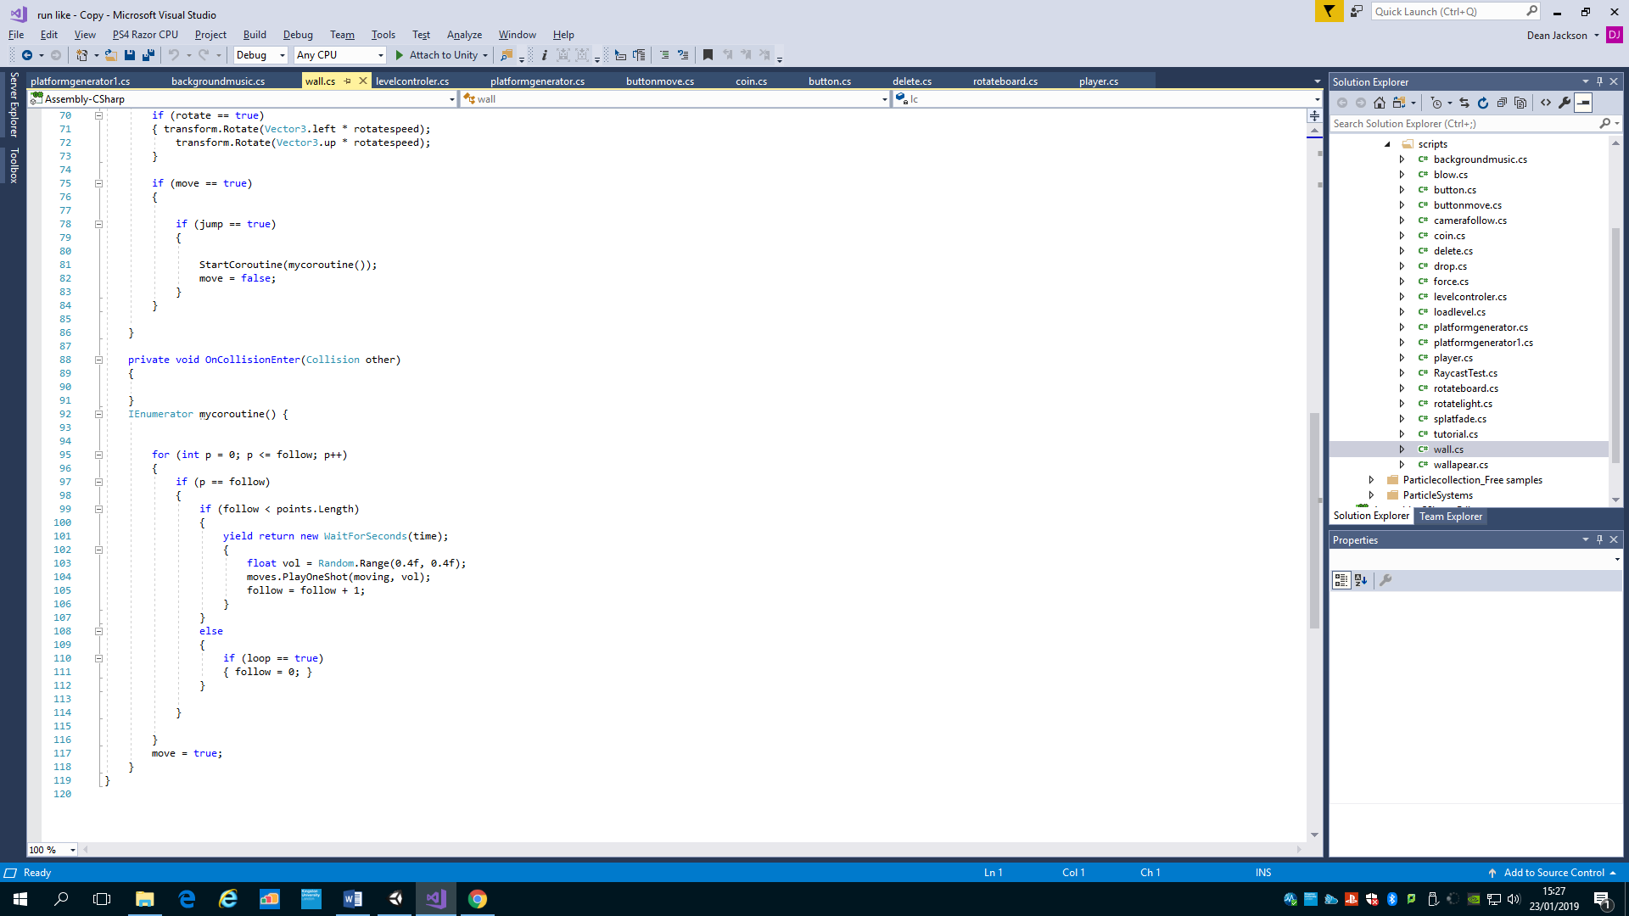

This give me flexibility to make the wall I want, the move, jump and time variables allow me to control each wall with the values I want, I can make static wall, or I could make a wall that moves slow but has a fast time before moving again.

Buttons

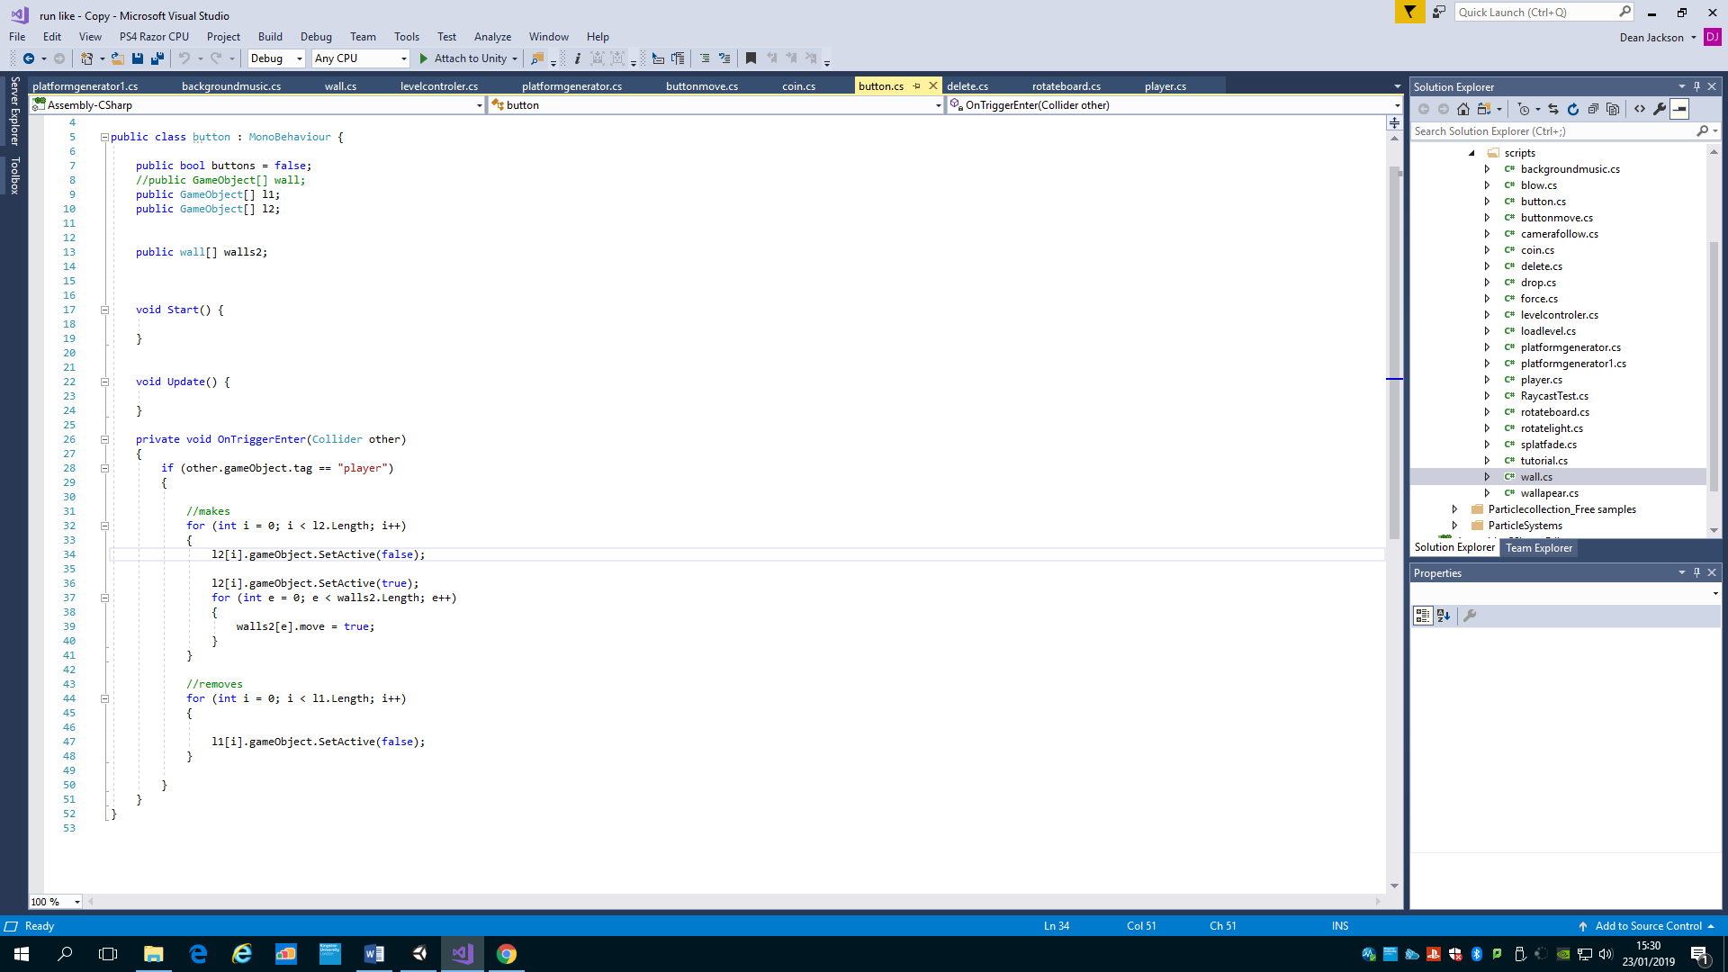

If the button collides with the gameobject then make any gameobjects in the l1array and remove any gameobject in the l2 array.

The button gives me control to change witch game objects are removed and witch are added. After the player has active it. The child gameobject attached will always be part of the removed objects so it changes the button.

Powerup interaction

Most of the powerup mechanics are handled in the player script.

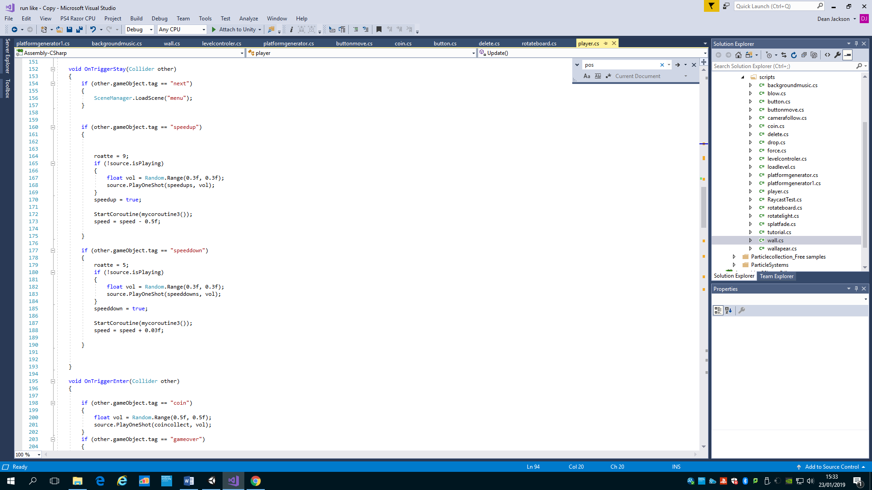

Ontriggerstay checks per frame if the player is colliding, if this gameobject collides with speedup then increase the speed, rotate less and play the sound effect.

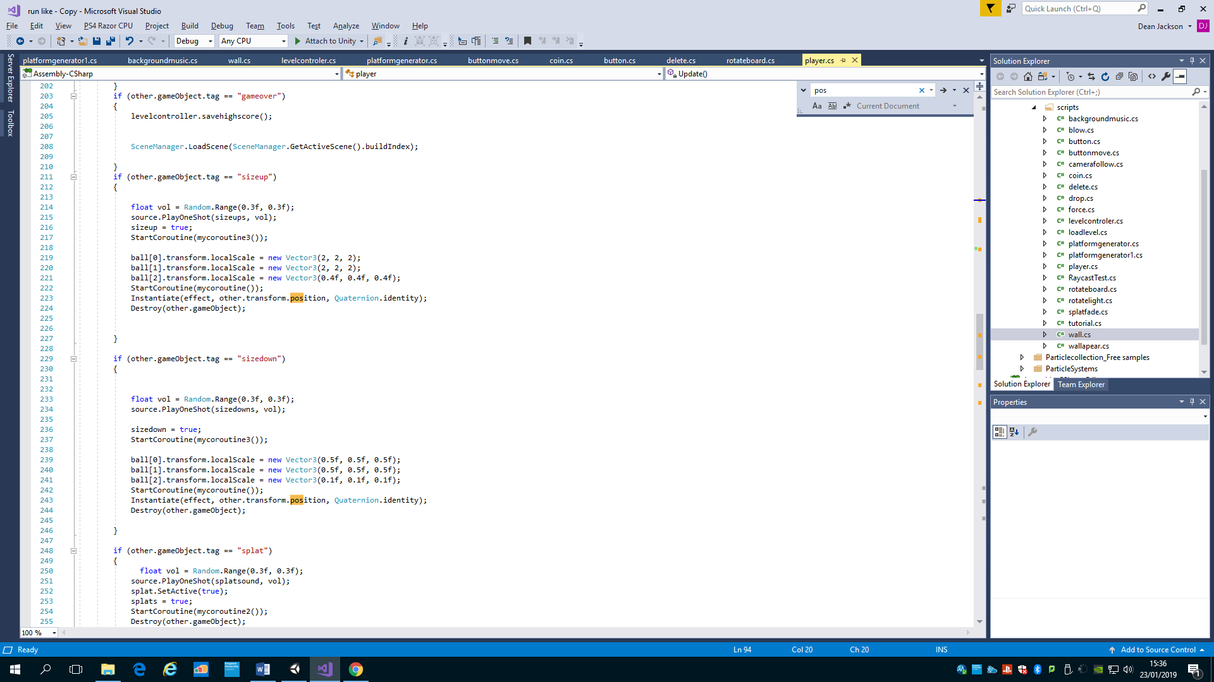

If the player collides with speed up then increase the size of the player and all the children, instantiate the effect, play the sound and destroy the other object.

Managing gameobejcts --- prfabs and placements

The splat object is a child of the main camera and is set active for 5 seconds if the player collides with the object, it plays the corutine witch slows reduces the alpha value of the colour and then is removed after 5 seconds.

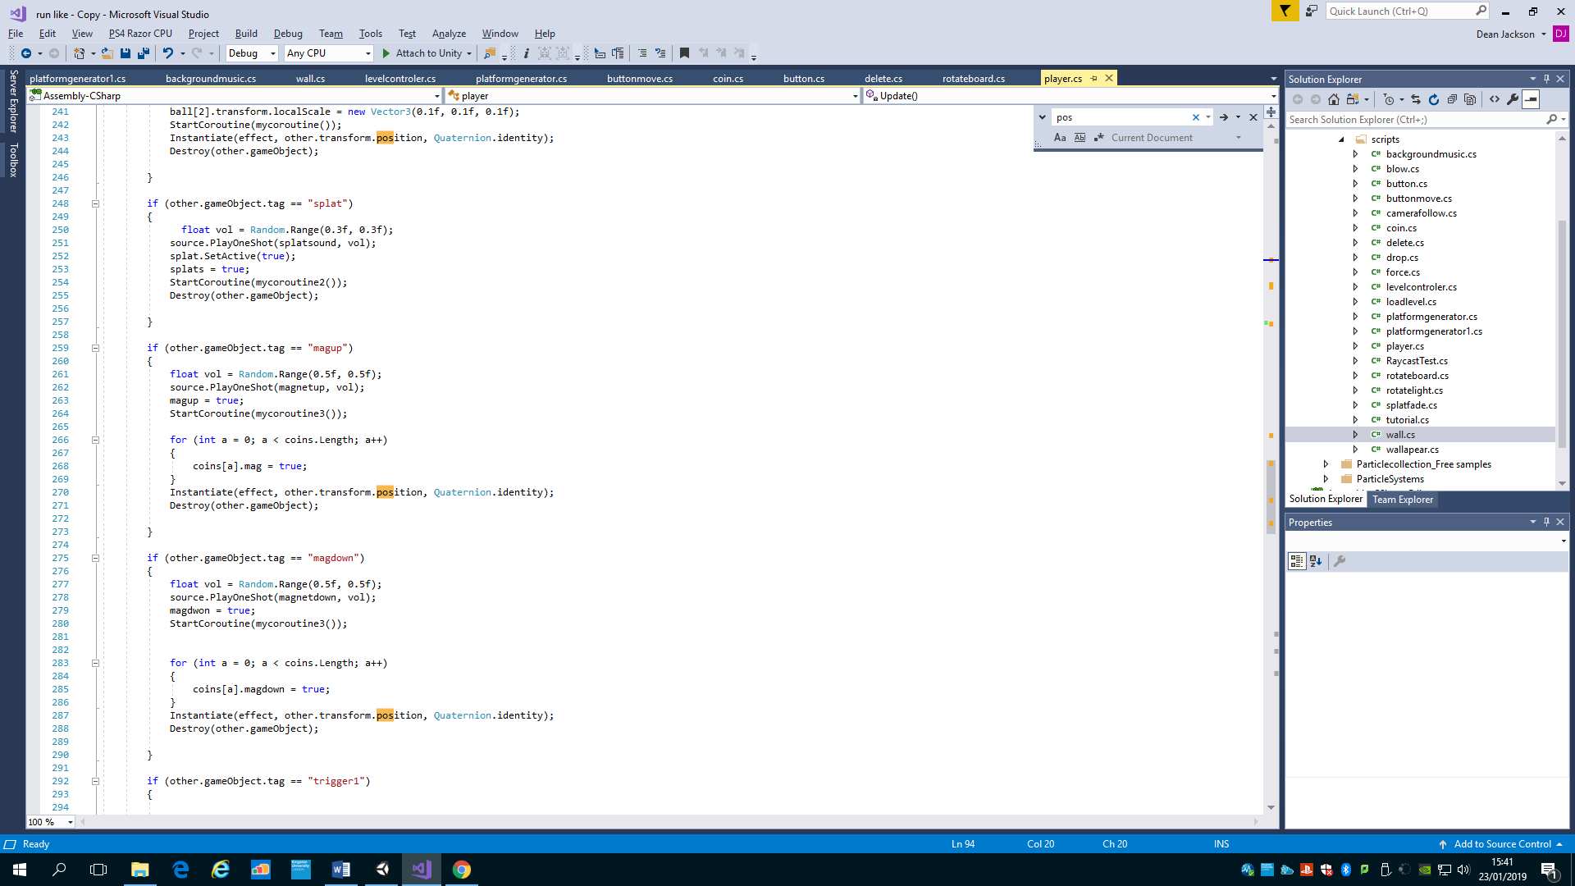

If the player collides with mag up it references the coin script and sets the variable magup to true, which then makes all the coins in the scene come towards the player at a given force. It also plays the sound effect and destroys the pick up.

In the coin script

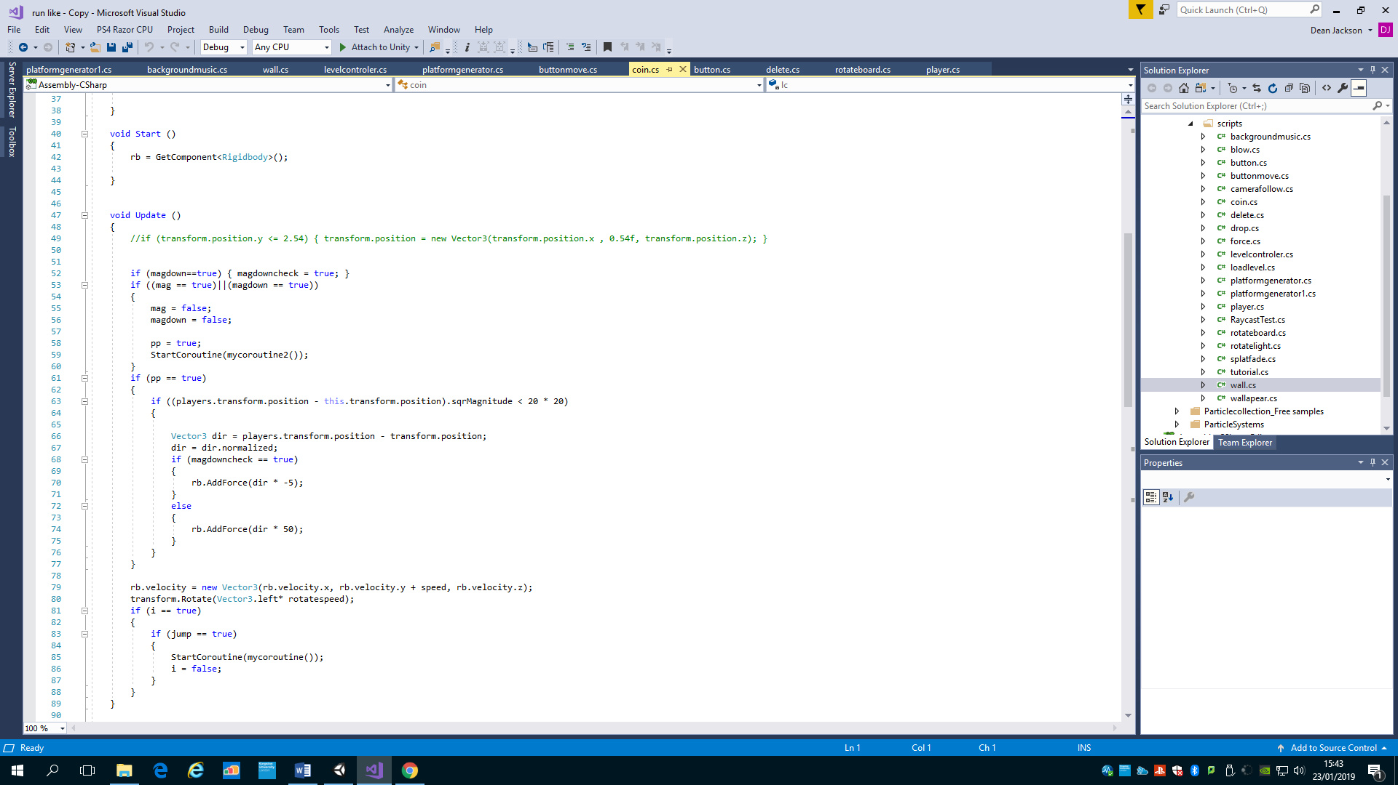

This checks to see if the variable magup is true and then preforms the action to work out the distance between the object and the player and push the coin in that direction.

This is all the powerups and effects in the game, each has their own unique functionality and uses other scripts and couroutine countdowns to create the effect.

Finishing touches

Some of the finishing touches included adding a skybox, adding barriers at the end of each plane and adding texture to all object that were just empty objects before.

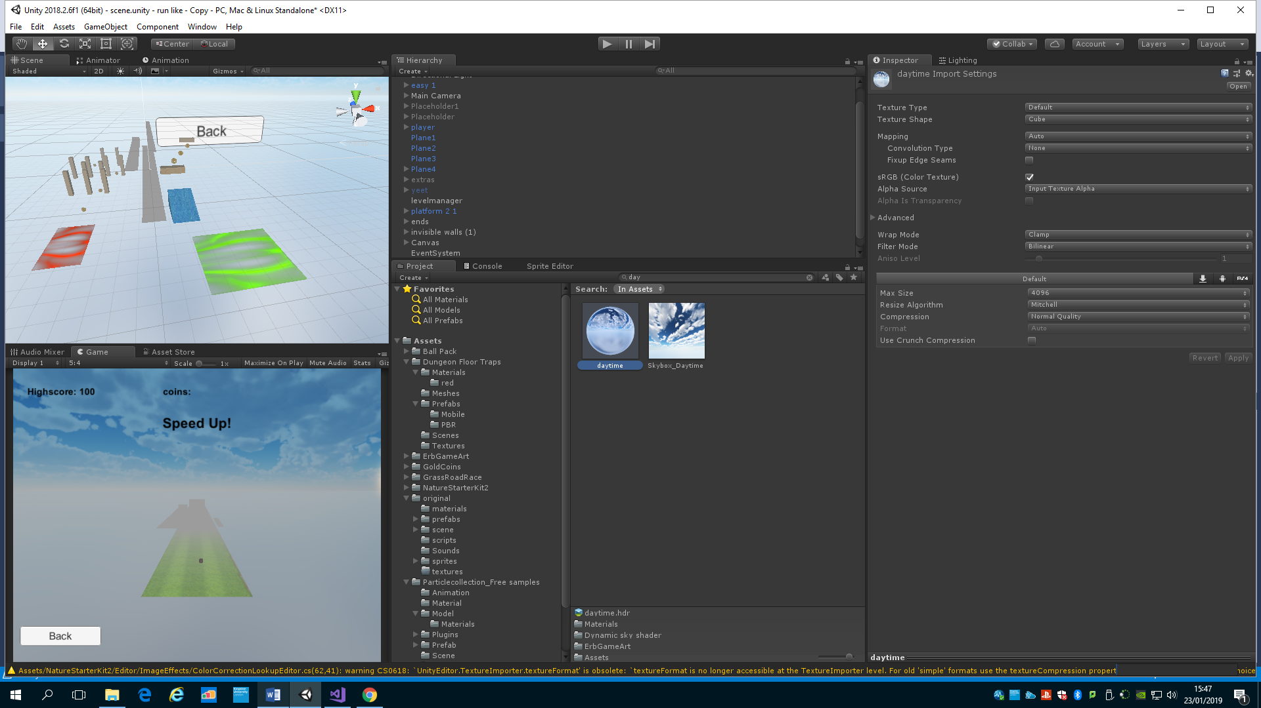

The skybox is a cube map witch is linked to the lightings skybox component.

I used the unity assets store to search for art assets that would fit in my game, I used a few from different packages to get the game looking how I want.

Bug checking

The final stage was to bug check my game and make sure it ran smoothly and correctly, I played it multiple times to check if everything was working correctly, if there was a problem I would think logically why that didn’t work and would find a fix for it. After I felt the game was in a stable point I let my friends and family play it and listened to their feedback and changed any problems or add new features that they would suggest. I achieved this by building the game on my phone and showing people as it was easily available.

Testing and Evaluation

I tested my game by implementing one mechanic and then playing around with it until it I felt satisfied it was working well and moved on to the next object. I would try different ways to solve any problems I faced and went with whatever seem most efficient or which one was more tailored to my game. I would bug test towards the end of the project and just get a feel and see if there was any problem or if anything needed fixing. After I felt the game was in a stable playable position I let my friends and family test it out and give options on it. One of them said something like “the game drops you straight in there no time to get used to the game” so I added a tutorial to fit that need, another friend said “it would be a great idea to add a push mechanic that pushes the player just enough to mess them up” so I added the pull portal. Using other people with a fresh set of eyes defiantly helped give me ideas and make a better game.

Management of the project

I self-managed my time by breaking down the tasks I had and giving them all different slots for different weeks. I also set all the “must” tasks first and then all the secondary tasks would come later. For example week one was setting up the scene and player movement and the final week was adding the skybox and bug fixing.

Legal, Social and Ethical Issues

In my proposal I changed a few elements I went for a more wild approach rather than a tied down farm endless runner and added more mechanics that I thought of at the time. I think this has made a better and more enjoyable game to play.

I would give my game a PEGI3 rating as there is nothing that goes over the criteria of a PEGI3 rated game and is intended for all ages.

I obtained most of my assets from the unity assets store or from Freedsound witch gives me all the rights to use them and are not copyrighted. The soundtrack is from another game witch is not copyright free but can change that if it ever gets released.

The game stores the players score but no personal information about them.

Conclusions

I am very pleased with what I have created I enjoy showing my friends and family what I have created, I have learnt and achieved many things along the way I have created random generation in an 3d endless runner style, I have managed to used high level programming concepts and applied them to my game. I have managed to make a build for my phone so I am able to show it wherever I am. I have created loads of interesting obstacles and power ups that the player can enjoy and I have managed to save the highscore inside the unity project so it can be referenced for another day. All of these achievement add up to a well-rounded and enjoyable experience.

I have learnt loads of new concepts from my work and it has increased my experience as a programmer and as a game developer. The problems I have faced made me learn to look for all possible ways around the problem and try to find the best on that works. This is a huge change from just keep changing it until something works. This will defiantly benefit my skills in the future and make me a more efficient programmer. I hope to use the concepts I have learnt from this game in the future.

Overall I am very proud of my game and have taken a lot from it.

Reference list:

<https://assetstore.unity.com/packages/3d/props/ball-pack-446>

<https://assetstore.unity.com/packages/3d/props/interior/dungeon-floor-traps-77765>

<https://assetstore.unity.com/packages/vfx/particles/spells/aoe-magic-spells-vol-1-133012>

<https://assetstore.unity.com/packages/3d/props/gold-coins-1810>

<https://assetstore.unity.com/packages/3d/environments/roadways/grass-road-race-46974>

<https://assetstore.unity.com/packages/3d/environments/nature-starter-kit-2-52977>

<https://assetstore.unity.com/packages/vfx/particles/particle-collection-skj-2016-free-samples-72399>

<https://assetstore.unity.com/packages/3d/environments/5-rocks-package-133702>

<https://assetstore.unity.com/packages/2d/textures-materials/sky/skybox-4183>

<https://freesound.org/people/qubodup/sounds/60013/>

<https://freesound.org/people/cabled_mess/sounds/350899/>

<https://freesound.org/people/JoelAudio/sounds/136542/>

<https://freesound.org/people/Link-Boy/sounds/156497/>

<https://www.youtube.com/watch?v=eYqUDmK-3cY>

<https://freesound.org/people/Anthousai/sounds/406270/>

<https://freesound.org/people/newagesoup/sounds/339359/>

<https://freesound.org/people/leviclaassen/sounds/107789/>

<https://freesound.org/people/KToppMod/sounds/266337/>

<https://freesound.org/people/kwahmah_02/sounds/262893/>

<https://freesound.org/people/cabled_mess/sounds/350869/>

<https://www.youtube.com/watch?v=HIsEqKPoJXM>

<https://www.youtube.com/watch?v=7KR5IKi8m8g>